TOWN OF 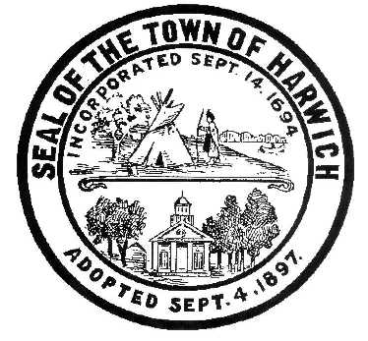 HARWICH
732 Main Street
Harwich, MA 02645
HARWICH CONSERVATION COMMISSION - MINUTES
PHONE (508)-430-7538 FAX (508)430-7531
WEDNESDAY APRIL 6, 2022 - 6:30PM

TOWN HALL - GRIFFIN ROOM – HYBRID PARTICIPATION

DUE TO A LACK OF QUORUM, THIS MEETING WAS CANCELLED AND ALL HEARINGS WERE CONTINUED TO THE APRIL 20, 2022.

The following applicants have requested a Change in Plan
Christina Hagopian, 0 Clearwater Dr, Map 73 Parcels P94 & P95. Reconfiguration of building footprint.

The following applicants have filed a Request for a Determination of Applicability
Joel and Lisa Winer, 51 Deep Hole Rd, Map 17 Parcel A1-40. Install patio and stepping stones, and reconfigure driveway.

Sandra Tanco, 17 Colonial Way, Map 15 Parcel S8-3. Addition and relocation of stairs.

Town of Harwich - Conservation, 0 Depot St, Map 36 Parcel M3. Relocation of fence and planting.

The following applicants have filed an Abbreviated Notice of Resource Area Delineation
Paul and Susan Cicco, 45 Neel Rd, Map 16 Parcel N1-41. Proposed Resource Area and Buffer Zone Delineation.

The following applicants have filed a Notice of Intent
Kathleen & William Lockyer, 280 Bank St, Map 32 Parcel A2-5. Pool and Walkway.

Bruce Soderholm, 27 Seventh St, Map 101 Parcel X3. Alter garage, upgrade septic, and appurtenances.

Mary & Andrew Pye, 41 Nons Rd, Map 5 Parcel W1-19. Pier, Ramp, Float, and Dredging.

Donald Annino, 14 Mill Point Rd, Map 1 Parcel J1-94. Proposed Pier, Ramp, Float, and Dredging.

Discussion and Possible Vote
0 Depot St – Discussion and vote regarding closure of gates to the Herring Run at Bells Neck during spawning season.

15 Glendoon Rd – Discussion of SE32-2420 for Gas Spill Remediation regarding ongoing reports, planting, and requirements for permit close out

Minutes
May 5, 2021
December 1, 2021
December 15, 2021
February 2, 2022
March 2, 2022
March 16, 2022

\

Respectfully Submitted,
Melyssa Millett
Approved on: 6/15/2022

