The Town of Harwich seeks to qualify as a Green Community, making the Town eligible for grants to assist with the reduction of energy use, saving the community money and lowering the Town’s carbon footprint. There are 5 criteria that must be met for the Town of Harwich to qualify as a Green Community:

- Adopt as-of-right siting, in designated locations, for Renewable or Alternative Energy: • Generating Facilities, or • Research and Development (R&D) Facilities; or • Manufacturing Facilities in designated locations
- Expedited Permitting
- Energy Baseline & 20% Energy Reduction Plan
- Fuel Efficient Vehicles
- Minimize Life Cycle Costs for New Construction (Stretch Code)

CRITERION 1: Adopt as-of-right siting for Renewable or Alternative Energy
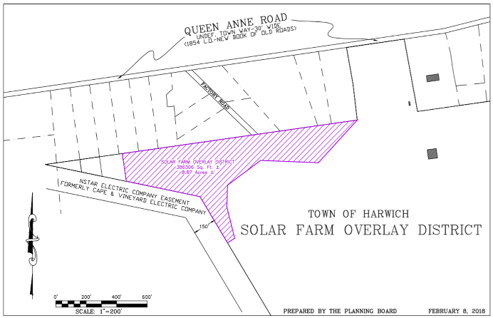
The Planning Board held a public hearing for the creation of a Large-Scale Ground-Mounted Photovoltaic (LSGMP) Bylaw. This would 1) Create a new Zoning Article LSGMP; 2) Adds the LSGMP to the Use Table; and 3) Adds a “Solar Farm Overlay District” to the Zoning Districts & Zoning Map (to be on Town Property, Adjacent to the existing PV array). Article 33 will be appear within the Annual Town Meeting Warrant

Article 33: This is a Zoning Bylaw article, it requires action at the May 7th Annual Town Meeting. A 2/3 vote is required to pass a zoning article. The Planning Board voted to recommend this article.

CRITERION 2: Expedited Permitting: The zoning bylaw proposed under criteria 1 would provide for expedited permitting.

CRITERION 3: Energy Baseline & 20% Energy Reduction Plan: Town staff and Energy Committee members are working on these two documents utilizing an existing Portfolio-wide Building Assessment prepared by Peregrine Energy Group, in Aug. 2016 and working with the MassEnergyInsight, which is a free, Web-based tool, that helps Massachusetts cities and towns to understand their energy use and reduce their carbon footprint by delivering customized, easy-to-use reports on electricity, natural gas, and oil use. The Town has also submitted an application to receive technical assistance from the Cape Light Compact through the Massachusetts Municipal Energy Technical Assistance grant.

CRITERION 4: Fuel Efficient Vehicles: The Board of Selectmen have to adopt a Fuel-Efficient Vehicle Policy requiring all municipal departments to purchase fuel-efficient vehicles, whenever such vehicles are commercially available and practicable; develop and maintain a vehicle inventory for all four-wheeled vehicles (this list already exists), and provide a plan for replacing non-exempt vehicles with vehicles that meet specified fuel efficiency ratings. NOTE: Police Cruisers and Heavy Duty Vehicles >8,500 pounds are exempt. This criterion applies primarily to administrative vehicles (Inspectors, Assessor, etc.)

CRITERION 5: Stretch Code This will be Article 32 with in the Annual Town Meeting Warrant for the adoption of the “Stretch Code”. On January 1, 2017, both the State’s Base Energy and Stretch Energy Codes were updated. The differences between the two are now much smaller than in the past. Basically, to comply with the Stretch Code, new residential construction in a Stretch Code town needs to follow the Performance Path of the Base Code rather than the Prescriptive Path. The updated Stretch Code also applies to all new commercial buildings over 100,000 square feet and new commercial buildings over 40,000 square feet if they are specific high energy users such as Supermarkets, Laboratory buildings, Refrigerated warehouses. All additions, renovations, and repairs to residential buildings are explicitly exempted from the Stretch Code. Also smaller new commercial buildings as well as additions, renovations and repairs of commercial buildings are exempt.
A key feature of the Stretch Energy Code is that it is performance based. It requires new homes to meet a HERS (Home Energy Rating System) index rating target of 55, rather than requiring the installation of specific levels of energy efficiency for each building element (e.g. Windows, Wall insulation, roof insulation, furnace etc.). The HERS rating is a measure based on a home’s total expected energy use and overall efficiency. It is calculated by a certified HERS rater using accredited software, which uses information on the design of the energy systems in a home to calculate the annual energy needs of the home and give it a rating score.
Currently 216 out of 351 communities, representing more than 71% of the state’s population, have adopted the Stretch Energy Code. Many builders are familiar with the stretch energy code. Many say that the energy efficiency trade-off features of the Stretch Code 55 HERS rating makes it easier to construct a Stretch Code home than a Base Energy Code home.

Article 32: As this is a General Bylaw adoption, this would require action at the May 7th Annual Town Meeting. A simple majority vote is required to pass a general bylaw.
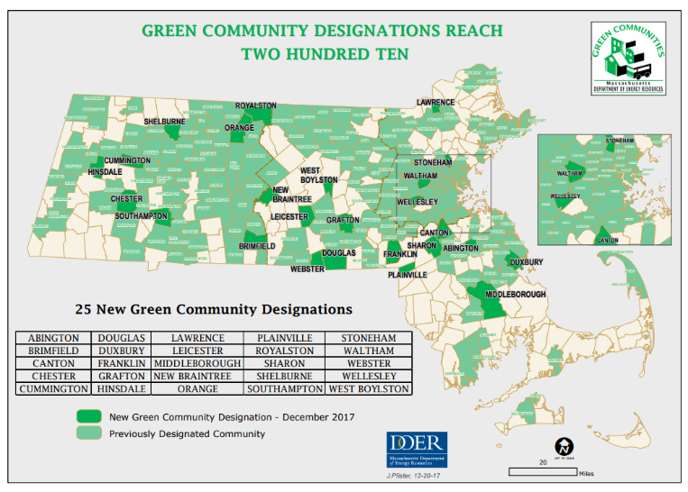
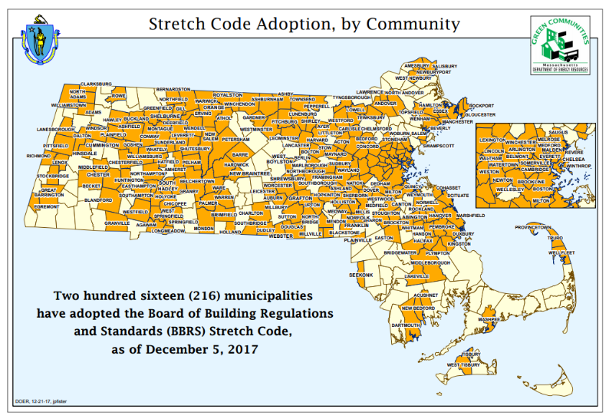
Learn more about Green Communities, read the latest updates, and sign up for the Green Communities email list. www.mass.gov/energy/GreenCommunities

