LEGAL NOTICE
TOWN OF HARWICH
REQUEST FOR INFORMATION
USE OR RELOCATION OF THE WEST HARWICH SCHOOL BUILDING

The Town of Harwich (the "Town") is seeking responses from parties interested in using or relocating the Town-owned Old West Harwich School building, located at 5 Bell’s Neck Road in West Harwich.

Responses should be marked “West Harwich School RFI” and are due at the Office of the Town Administrator, 732 Main Street, Harwich, MA 02645 NO LATER THAN 2:00 PM on Monday, April 10, 2017. Five copies are requested for those respondents who choose to submit hard copies. Responses also may be submitted electronically to srobinson@town.harwich.ma.us.

Further details are available at the Office of the Town Administrator at the above address or by calling to request them at (508) 430-7513 Monday from 8:30 A.M. to 8:00P.M., Tuesday through Thursday from 8:30 A.M to 4:00 P.M. and Friday from 8:30 A.M. to 12:00 Noon. Questions regarding this project shall be submitted to Aly Sabatino, Town Planner, at (508) 430-7511.

Christopher Clark,
Town Administrator

Central Register
Date of Publication: 2/27/17

Cape Cod Chronicle
Date of Publication: ____

Request for Information

USE OR RELOCATION OF WEST HARWICH SCHOOL BUILDING

SECTION I INTRODUCTION
The Town of Harwich (the "Town") is seeking responses from parties interested in using or relocating the Town-owned Old West Harwich School building, located at 5 Bell’s Neck Road in West Harwich. Submissions shall be received no later than 2:00 p.m. on Monday, April 10, 2017 at the Office of the Town Administrator, 732 Main Street, Harwich, Massachusetts 02645.

All potential submitters are encouraged to attend an on-site to inspect the premises on March 17, 2017 at 10:00 am. Please contact Aly Sabatino, Town Planner, at (508) 430-7511, prior to March 15, 2017 if you plan to attend.

SECTION II BACKGROUND

The Old West Harwich School was built in 1871. It is a two story building with one large room and office, and a men’s and ladies’ room on the first floor and one large room, and a kitchen on the second floor. The building has not been used for some time and the windows are boarded up. The Town is committed to maintaining the historic facade of this building by seeing that it is restored to the Secretary of the Interior’s Standards, either at its present location or a new location.

SECTION III POTENTIAL USES

If the building will not be dismantled and relocated, it is the intention of the Town to seek uses that will benefit the public and complement the surrounding West Harwich area. Potential uses identified to date are artistic, cultural or educational activities. Other uses also may be proposed provided the use(s) are consisted with the zoning district.

The Town’s intention is to enter into a license agreement with a potential user similar to the Town’s license agreement for the South Harwich Meeting House. A copy of that agreement is available upon request from Aly Sabatino, Town Planner.

SECTION IV BUILDING CONDITION

A structural evaluation of the former West Harwich School was performed by Coastal Engineering Company in 2007. A copy of that evaluation is included in the appendices. A potential user of the building in its current location shall be responsible for restoring the historic character of the building along with any other necessary improvements. If the building is to be relocated, the purchaser of the building shall be responsible for restoring the historic character of the building.

SECTION V SITE REQUIREMENTS

The Town’s intention is to either entertain the relocation of the West Harwich School or entertain uses that will not expand the building beyond its existing footprint.

Use of the overall site shall include the following considerations:
- If the use is not a not-for-profit then the use shall be consistent with the zoning district.
- The submission must include sufficient parking spaces on the site to serve uses in the building and elsewhere on the property.
- Any exterior use of the property shall be secondary to use of the historic building and shall be compatible with neighboring properties.
- The site will require maintenance of an on-site septic system to serve all proposed uses on the property.
- The building and site must be compliant with the American with Disabilities Act (ADA) and local disability access laws.

Bennett Environmental Associates performed an environmental site assessment in 2010 of a possible groundwater contamination at this site migrating from a release that occurred at the Dennisport automatic coin laundry, located approximately 2,000 feet southwest of the site. The report is available from Aly Sabatino, Town Planner, upon request. An e-mail message from Massachusetts DEP regarding the current status of the site, is included in the appendices.

SECTION VI INFORMATION TO BE SUBMITTED

The Town seeks the following information from interested parties. Your responses are for informational purposes only and will not result in any contractual obligation on your part. Please note that your response will become a public record.

- Description of building relocation: Please describe in as much detail as practical how you propose to dismantle and relocate the building. Additionally, describe where the building will be relocated.
- Description of use. Please describe in as much detail as practical how you propose to use the property in its current location. Describe what portions of the building and/or property you intend to use. If you propose more than one use, please describe each separate use.
- Financial benefit/cost to the Town
  - Will you compensate the Town for the sale of the building and cover all costs associated with relocation?
  - Will you provide annual lease payments to the Town?
  - Will you pay for all operating costs associated with your use?
  - What type of Town services will your use require?
Please note – while final cost information is not required with this RFI, any estimates that you provide for the sale and relocation of the building, lease details, operating costs, and cost of Town services will assist the Town in deciding whether to support your proposed use.
- Other benefits to the Town
  - Does your proposed use support goals of the Harwich Local Comprehensive Plan or other approved Town plans? Please specify.
  - What is the need in the community for your proposed use? Please specify.
- Impact on the neighborhood
  - Will your proposed use complement the West Harwich area? Will it be incompatible in any way, and how will you mitigate any potential adverse impacts?
  - What adverse impacts may be created for residents in the vicinity, and how will you mitigate such impacts? Please consider construction, type of use, traffic, noise, lighting, appearance, and any other relevant impacts.
- Ability to perform
  - Please describe your experience with relocating buildings or in the alternative, the development and operation of your proposed use.
  - Please describe your financial capacity to dismantle and relocate the building or in the alternative, develop and operate the proposed use.

We welcome any additional suggestions or feedback you might have as we evaluate possible future uses.

SECTION VII SUBMISSION

Responses should be marked “West Harwich School RFI” and are due at the Office of the Town Administrator, 732 Main Street, Harwich, MA 02645 NO LATER THAN 2:00 PM on Monday, April 10, 2017. Five copies are requested for those respondents who choose to submit hard copies. Responses also may be submitted electronically to srobinson@town.harwich.ma.us.

APPENDICES

- Structural Evaluation, Former West Harwich School, prepared by Coastal Engineering Company, Inc., September 20, 2007
- E-mail message from Jan Niemiec, Hydrogeologist, MassDEP
COASTAL ENGINEERING COMPANY, INC.

260 Cranberry Highway (Rte. 6A), Orleans, MA 02653
www.CoastalEngineeringCompany.com
Orleans 508-255-6511
Provincetown 508-487-9600
Hyannis 508-778-9600 Fax 508.255-6700

September 20, 2007 Project No. C16896.00

Menders, Torrey & Spencer Inc.
Attn: Brian Mulligan
123 North Washington St.
Boston, MA 02114
RE: Structural Evaluation
Former West Harwich School, Harwich, MA

Dear Mr. Mulligan:

Pursuant to your request and subsequent authorization, personnel from our office conducted a field investigation of the referenced property on 5/25/07 and again on 6/07/07. The purpose of this investigation was to assess the general condition of the existing schoolhouse and determine the nature and condition of the first floor, second floor, roof, and foundation systems. The following report summarizes observations noted during our investigation and presents comments and recommendations for the proposed retrofit design foundation.

LIMITS TO INVESTIGATION

Due to the restricted access of the crawl space beneath the first floor framing and to existing finishes on the second floor framing, it is impossible to assess all of the existing conditions pertaining to the integrity of the floor framing and supports. While every effort has been made to employ our knowledge of standard construction techniques and established engineering principles to determine member loads, stresses, etc., it is beyond the scope of this investigation to thoroughly assess every element of the existing floor framing. Our report and as-built framing plans are therefore limited to typical conditions found in the areas observed.

OBSERVATIONS

General

The project consists of a two and one-half story federal style building. The windows and doors in the building are boarded up and the building has been vacant for some time. The siding appeared to be vinyl with an asphalt shingle roof. Based on pictures from Coastal Engineering Company, Inc. previous report dated February 9, 2001 some siding work has been done on the west side of the building. There is a limited crawl space under the building and there is a walk-up attic. The building does not appear to have any additions; however, it is evident that the building has undergone some degree of renovations over time. For the purpose of this report, the south side of the building will refer to the side that faces Route 28.

Foundation

It appears that the foundation of the schoolhouse has had foundation repairs done at the southeast corner. There are now CMU blocks where it appears brick masonry once existed. Also by this area, under the south stairs, a lower row of bricks appears to be missing. It is likely that animals use this area to gain access into the crawl space of the building. The northwest corner of the building has had similar foundation repairs to that found on the southeast corner of the building. At the southwest corner of the building, the foundation shows signs of minor cracking and separation. On the east side of the building there is a small access way to the crawl space below the first floor.

In the crawl space at the approximate center of the building there are 5 masonry piers running the long length of the building. The piers are of approximately l5"x11" in size with a beam supporting the first floor resting atop. The spacing of the piers varies with a maximum span of approximately 8 feet 6 inches. The piers appear to be in good condition with little deterioration of the bricks. The mortar shows more deterioration than the bricks do, but appear to have good adhesion to the bricks. Also located in the crawl space is a stub wall approximately 4 feet 4 inches from the north wall, and extends from the east side of the building to approximately 18 feet out from the exterior wall. The wall consists of a 7"x7" bottom beam resting on the soil below. The beam appeared to have approximately 2 inches of deterioration on the portion of the beam in contact with the soil. The studs consist of 4"x 3" posts that align directly below and support the 1st floor joists. The studs appeared to be in good condition with little to no deterioration. There is also an approximately 3 foot by 4 foot by 3 foot deep pit in the crawl space. The pit is located directly under the interior access way to the crawl space, and is supporting the surrounding crawl space soil with 3 foot high, 8" CMU retaining walls.

Sill

The sill appeared to be 7" x 8" lumber resting atop the masonry foundation. The sill appeared to be in good condition with little deterioration observed. The first floor joists appear to rest on top of the sill, at the north and south sides of the building. There was no visible connection between the sill and the foundation wall, at the locations viewed.

1st Floor

The first floor framing appeared to be 3"x 8" joists spaced approximately 19 inches on center. The joists appeared to be in good condition with little deterioration observed. The joists spanned from north to south of the building with two simple spans resting on the 7" x 8" beam that is in turn bear on the uniformly spaced masonry piers in the crawl space. There did not appear to be any bracing between the joists at any of the observed locations. There is a 30"x 24" opening in the first floor framing to allow access to the crawl space below. This opening is relatively new and is framed with newer dimensional lumber.

2nd Floor

The second floor framing was observed at two locations where the first floor ceiling finishes had been removed. It joists appeared to be 3"x 12" joists at 18" on center at the locations observed. The joists appeared to be in good condition with no deterioration visible on the joists that were observed. At both locations viewed there did not appear to be any bracing present between the joists. It was also observed that some joists in the northeast corner of the building appeared to be resting on a 2x4 ledger board attached to the exterior stud-bearing wall. Most of the second floor joists are clear spans from north to south of the building. There are some joists in Multipurpose Room 1 being supported at mid span by a beam resting on 6" circular steel columns running east to west. The beam supporting the second floor in the Multipurpose Room 1 is 7"x7"xl7' long and is centered in the room, this beam does not extend the entire length of the building. The posts that support the beam appear to be supported by the center beam supporting the first floor. However, it does not appear that the beam in the first floor is supported directly under the posts. There appeared to be water damage and mold present on the ceiling in Multipurpose Room 1, possibly from a ruptured water pipe.

Attic Framing

The attic framing consists of 3"x 9" joists at 18" on center to span the length of the attic the joists were spliced at the center of the building. Along with being connected with nails the floor at this location was also supported by a board typically a lx of various with widths to the roof peak. The attic has no flooring material present and has insulation filled between the joists. There was a framed opening in the attic in which two chimneys pass through. It appeared that both brick chimneys changed to metal ductwork in the attic and exhausted out through the roof. The connection of the roof rafters to the top of the wall was not observed due to restricted access though it is believed that the connection is inadequate based on current code, this is based on knowledge of common construction practices of the time.

Roof Framing
The roof framing consists of 3"x 8" rafters spaced approximately 30" on center. Rafters are clear span from cave to peak, with no ridge board or beam present at the peak. There was no blocking or bridging that was present in the roof rafters at the observed locations. Some insect damage was noticed and appeared to extend about''/." in depth into the rafters. There also appeared to be the water staining to some of the roof sheathing and roof rafters due to compromised roofing (refer to Coastal report dated February 9, 2001). The extent of the water staining and insect damage was not fully determined. Some of the roof rafters on the north east corner have been cut to allow for roof penetrations, this change from the original roof design does not appear to be adequate based on visual inspection and engineering mechanics.

GENERAL RECOMMENDATIONS
Based on our preliminary observations, it appears that the structure is in need of structural repair and overall general upkeep repairs along with reinforcing required to conform with current code. The following repairs and evaluations are suggested.
- Foundation and interior masonry piers should be repainted, and repaired as needed.
- Based on Coastal Engineering Company, Inc. previous report dated February 9, 2001 foundation does not have adequate ground penetration or bearing capacity.
- First floor live loading should be limited to 44psf, which is equivalent to typical residential home loading. This loading can be increased by properly reinforcing the first floor beam and joists. This loading is also assuming that the second floor beam is replaced with one coming down at proper support locations.
- All second floor joists should be reinforced/supported as close to mid span as possible. It is suggested to place a beam at the location of the current beam in Multipurpose Room 1, but the new beam should span from the west exterior wall to the inner wall by the chimney. The beam should then continue to the east exterior wall. There appeared to be a masonry pier next to the chimney that may support a column for the new beam.
- The second floor joist resting on the 2x4-ledger board should be better secured to the exterior wall. It is recommend replacing the existing ledger board with a larger one and attaching the joists flush with the new ledger board with joist hangers.
- Second floor loading should be limited to 38psf, which is equivalent to typical loading of a bedroom. This can be increased to 60psf if a properly sized new beam is installed to support all of the 2nd floor joists at mid span. This is equivalent loading to offices or library reading rooms. Reinforcing the floor joists can further increase load capacity of the 2nd floor.
- Attic loading is limited to approximately l0psf live load to limit deflection. Current code requires an attic space of this type found in the west school to have a minimum live load capacity of 20psf. In order to achieve this minimum capacity, reinforcing of the joist would be required.
- Roof rafters appear to be adequate for current snow loading prescribed by code. But should be reinforced with collar ties, and hurricane straps.
- Vertical ties in roof system need to be reinforced to limit attic deflection.
- New roof shingles should be installed to minimize water damage to the roof system.
- At time of roofing, connection should be verified and condition of connection determined of roof sheathing to roof rafters.
- Siding should be removed from a section of the building to expose any previous siding, and exterior sheathing to determine the condition of the underlayment.

CONCLUSION

The Harwich West School, although needing structural augmentation, is in good condition. Since the building is not in use at present, the framing does not need to be reinforced at this time. If the building is opened for use, then it is recommended that screw jack lallies with new footings be used between the current supports of the main wood beam supporting the first floor. We also recommend that the second floor use be limited to small groups of 50 or less at a time until the joists are reinforced/mid span support is added for the length of the building. The roof should be reshingled to prevent any further water damage to the building. Minor foundation repairs are needed, mainly consisting of repointing of interior brick piers and brick replacement under the front entrance. Of course, since this building has been abandoned for some time, several other architectural and building technologies improvements will be needed before opening.

Please contact us if you have any questions concerning the above report.
Very truly yours,

COASTAL ENGINEERING CO., INC.
JMD/dlb

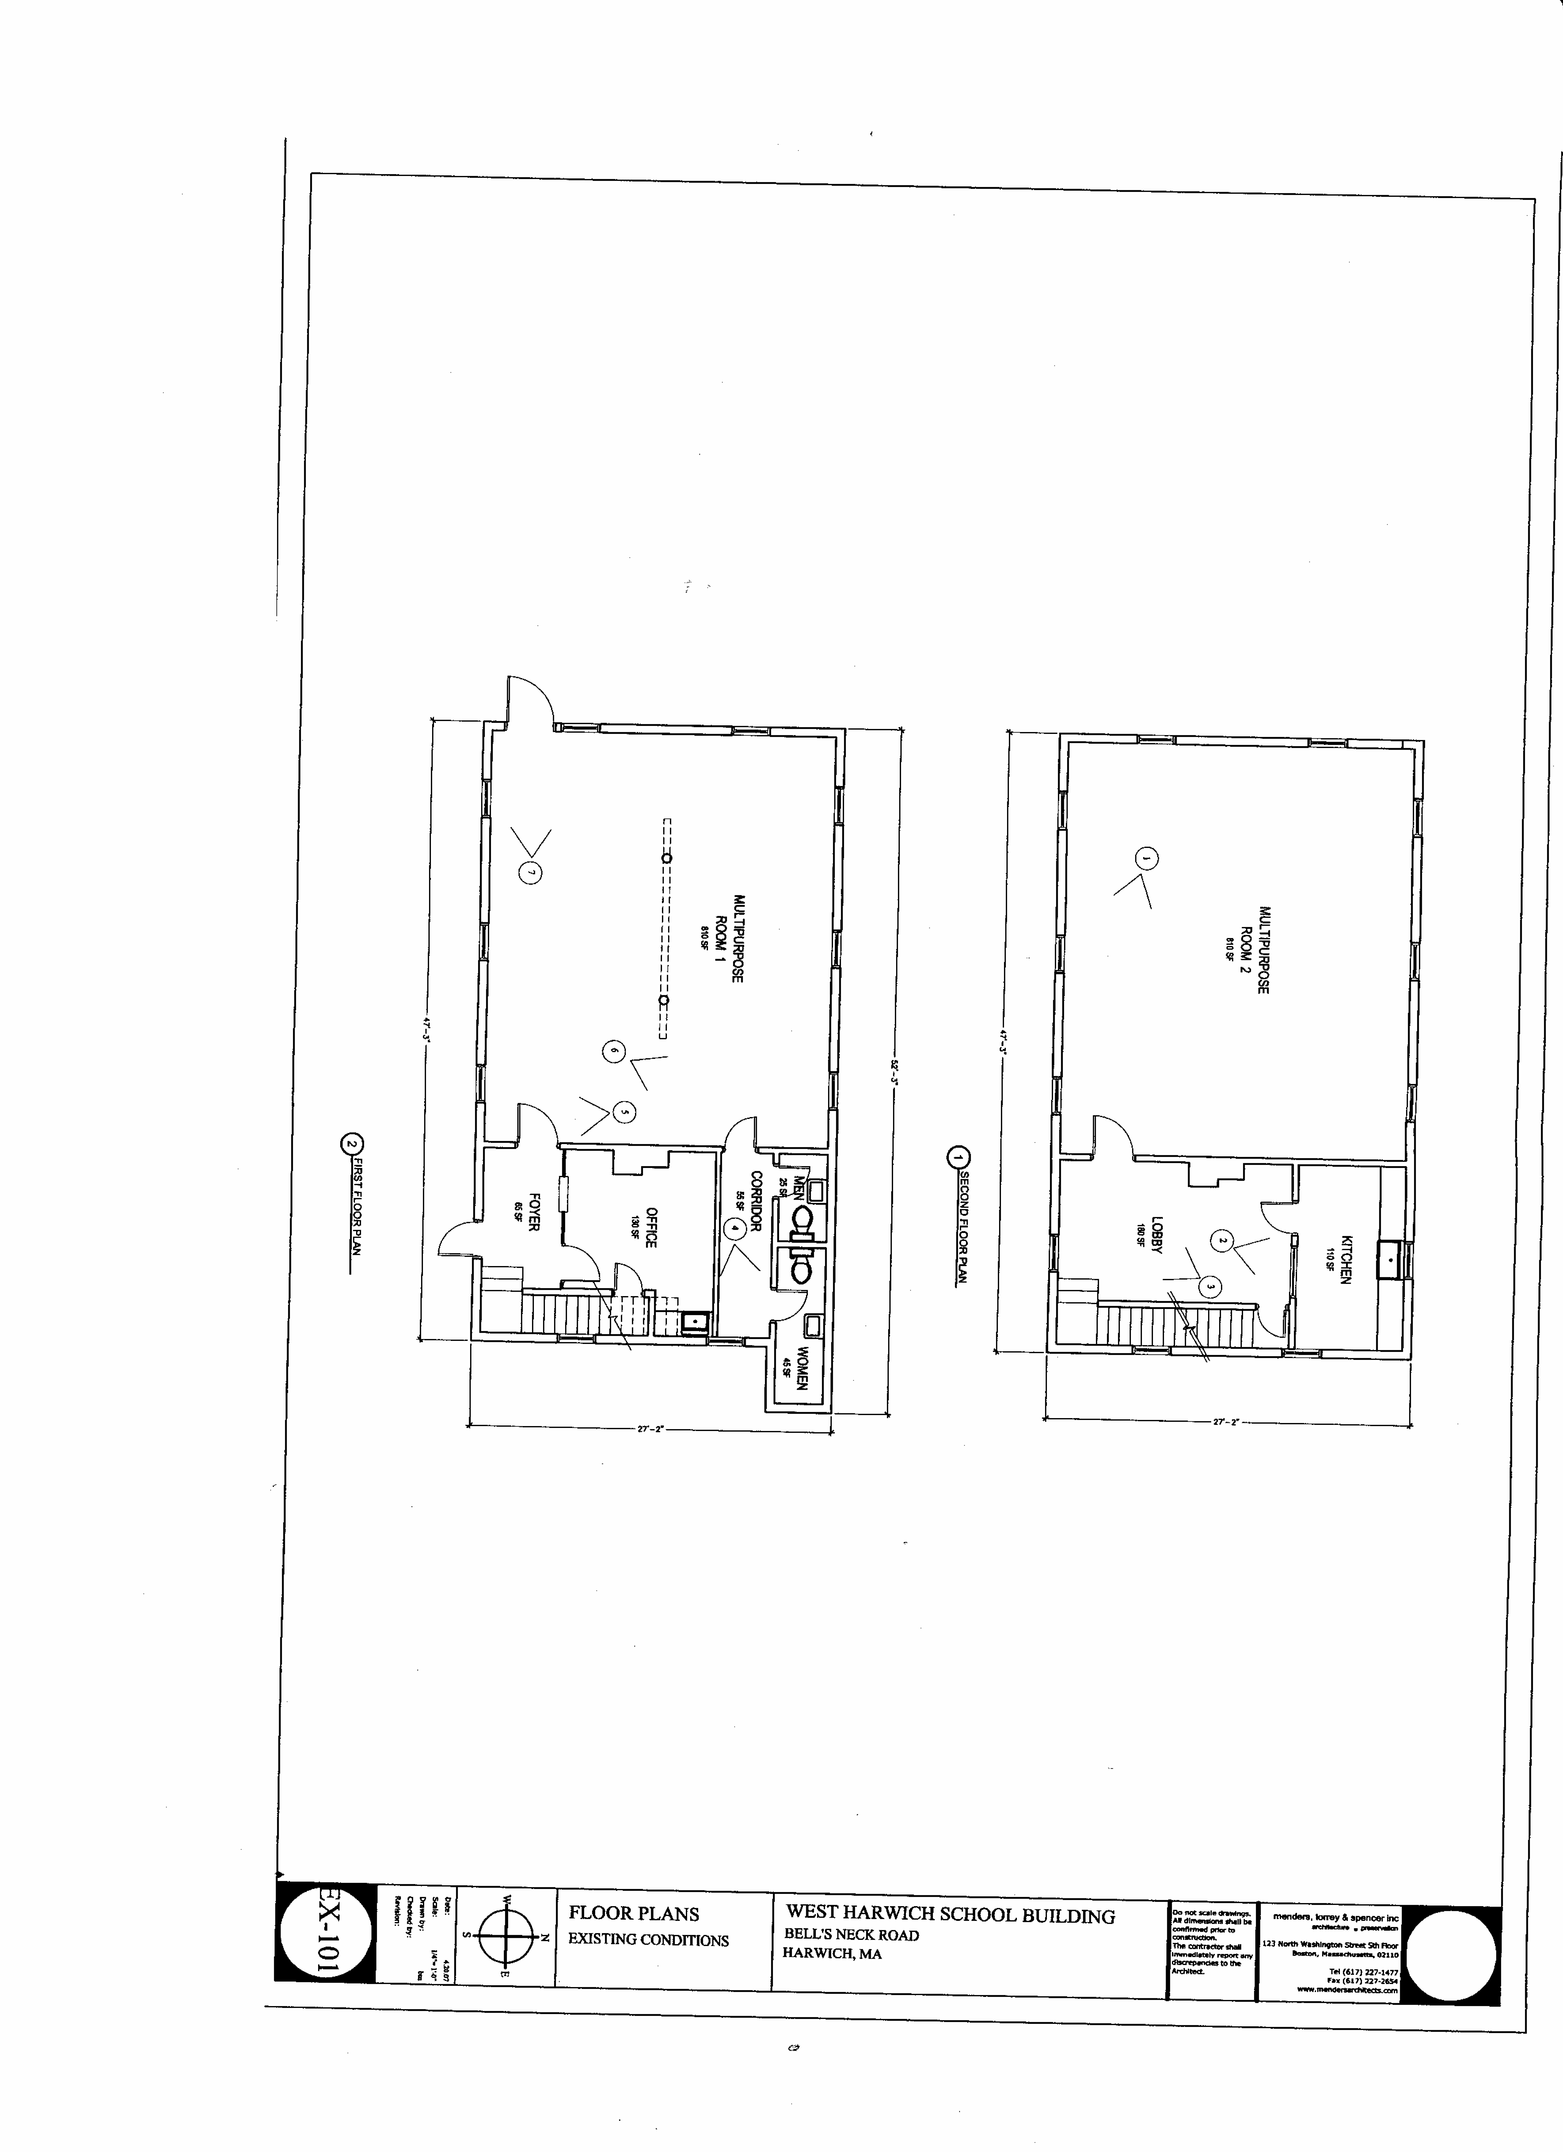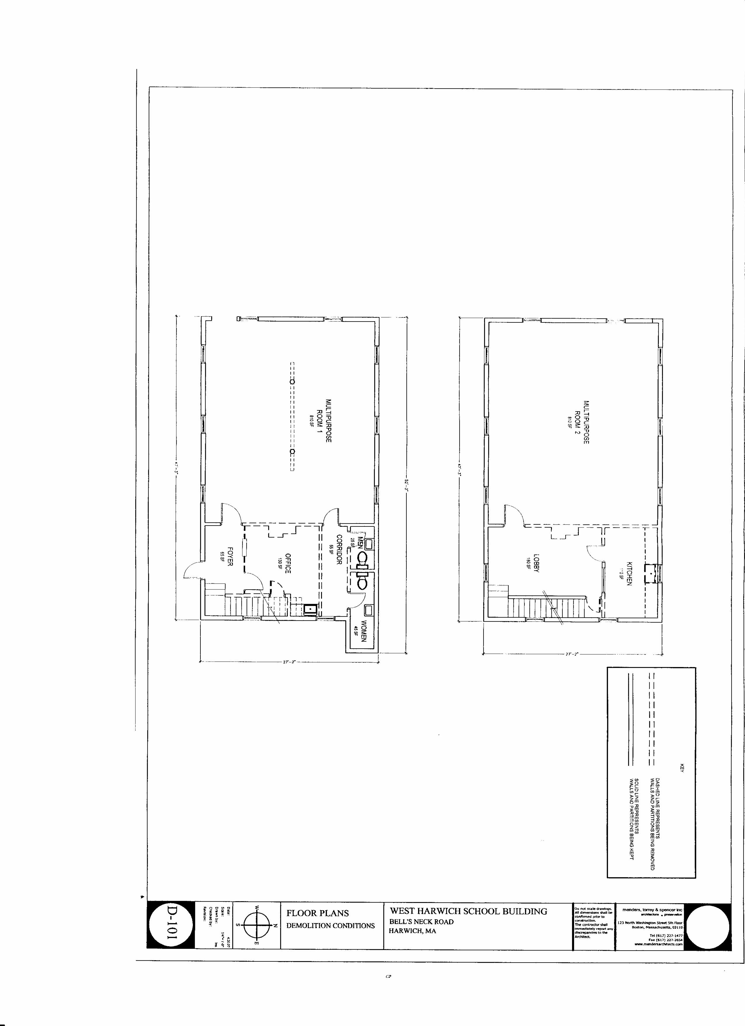

http://public.dep.state.ma.us/fileviewer/Rtn.aspx?rtn=4-0013326

The link, above, is to the webpage in the MassDEP sites database that pertains to the Bell’s Neck property investigations.

As you will see, there is only one file under the “Electronically Submitted Files” tab. This is because the work was performed prior to the full implementation of MassDEP’s electronic record keeping system. It was not until 2009 that LSPs were required to only submit their work electronically. MassDEP prior to that had kept paper files, and once the electronic system was up and running, began the long process of scanning and uploading older files. So – to view the older files, click on the Scanned Files tab, then, click on the “Submit Date” column of the table of records and all records will be presented in the order in which they were submitted. The Release Tracking Number (RTN) for this site is RTN 4-0013326.

As you are aware, this site came to MassDEP’s attention after routine water supply testing of a deep well that served the residences on the property tested positive for chlorinated volatile organic compounds (cVOCs) including some that are typically used in dry cleaning operations. Investigations were required to determine whether the contamination originated on site, or came from an upgradient source. Shallow groundwater was the issue: if it also were contaminated at the Bell’s Neck property, this would suggest an on-site source. If it were only found at depth, however, that would provide evidence of an upgradient (in terms of groundwater flow) source.

Wells were installed at different depths on the subject property and tested for contamination. Briefly, results indicated that the contamination was found at depth only. This work was performed under an IRA Plan, a Supplemental IRA Plan, and results reported in an IRA Completion Report. Because the evidence pointed to an upgradient, rather than on-site source at the Bell’s Neck property, a Downgradient Property Status Opinion was filed pointing to potential upgradient sources.

Meanwhile, a greater area of the aquifer underlying Harwich and Dennisport was under similar investigations by MassDEP, and the data found in this much larger area dovetailed with the data and conclusions reached for the Bell’s Neck Property. This is all described and contained in the 3/31/2003 submittal of the Harwich PCE/TCE Study Area Site Investigation Report. Figure 3 of this report presents a cross sectional view of the aquifer, which indicates the presence of cVOCs as not being present at the Bell’s Neck Road area in shallow groundwater. Figure 4 presents the groundwater contours, flowing approximately to the northeast from the apparent source area in Dennisport. The plume of cVOCs flowing through the aquifer at that time appeared to be, appropriately, shallower at its point of origin, deeper as it proceeded toward the Bass River, where it appears to rise to the discharge to the river. Also, as you are aware, the contaminated deeper well at the Bell’s Neck property has been abandoned, and water is now supplied from the Town’s municipal system.

I hope the preceding is sufficiently clear – any questions, please give me a call.

Jan Niemiec, Hydrogeologist
MassDEP 20 Riverside Drive, Lakeville, MA 02347
(508) 946-2841 PHONE /(508) 947-6557 FAX

