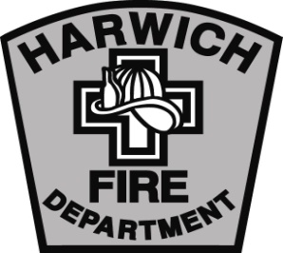

HARWICH FIRE DEPARTMENT

Norman M. Clarke Jr., Chief of Department

Kent J. Farrenkopf., Deputy Chief

MEMORANDUM

November 2015

To: Station 2 Study Committee

From: Chief Clarke

Re: Formation of the Committee

The Town Administrator has asked me to form a committee to evaluate the physical needs of Fire Station 2 in East Harwich. The committee’s charge is rather broad in scope. I anticipate the committee taking a reasonable amount of time to look at the present condition of Station 2 and project out the mission for that station. Included in our work will be repairs, expansion and possible replacement or relocation of the building. Considerations need to be given to the growth of East Harwich, the additional services now being required by Fontaine Urgent Care and possible future regional plans.

Committee members are:

- Chief Norm Clarke
- Captain John Clarke
- Firefighter Joe Rego
- Attorney Joe McParland
- Craig Chadwick, retired Insurance Executive, member of the HFD Photo unit

Please respond to my email with your contact information, phone number(s) address and mailing information. Thank you for your participation.

