TOWN OF HARWICH
WATERWAYS COMMITTEE
Harwich Fire House Conference Room
Wednesday 10, 16 , 2019
6:00 PM
MINUTES
Call to Order: 6:05pm
Members Present: Matt Hart, Chairman; Roger Peterson; Steve Root; Joe Johnson; and Tom Themistos.
Members Absent: Mort Terry, Vice Chairman; Jay Walpole; Dan Casey; and Dan Hall:
Others Present: John Rendon, Harbormaster; Heinz Proft, Natural Resources Director; Matt Farrell, J.M. O'Reilly & Assoc, Inc; and Bob Dutra, Guest:
MINUTES: Motion made by Steve Root to Approve the Minutes for September 18, 2019, Seconded by Joe Johnson. All members were unanimous.

FINANCIAL REPORT YTD & MONTHLY:
Presented by Steve Root and Harbormaster Rendon
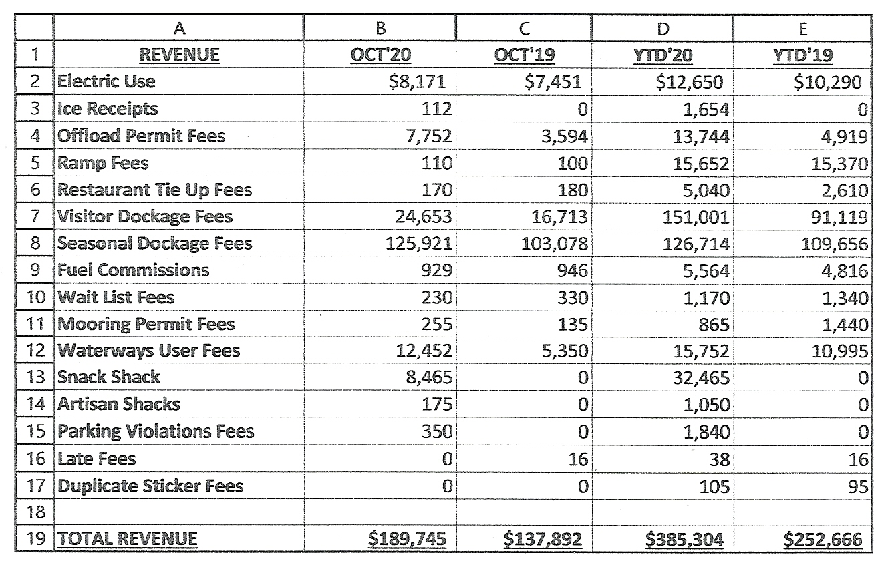
NEW BUSINESS:
- John & Ileana Chandler: Requesting Permit for existing dock;
at 115 Sequattom Road - J.M. O'Reilly & Assoc, Inc. A motion was made by Joe Johnson to accept the Revised plan dated 10/8/2019, Job # JMO-8613, seconded by Tom Themistos All members were unanimous

OLD BUSINESS: None this month

MONTHLY REPORTS:
Board of Selectmen nothing this month
Harbormaster: Harbormaster Rendon updated on winter boat storage.
Natural Resource Director: Natural Resources Director Proft updated on the Hinckley Pond treatment which has been completed and is already having a positive effect. Will take up to 20 years to see final results.

CORRESPONDANCE: None this month

NEXT MEETING: Wednesday, November 20, 2019 6:00PM

ADJOURNMENT: Motion by Steve Root to adjourn at 6:38PM, seconded by Tom Themistos. All members voting in favor.
Minutes recorded by Leah McPherson

Chairman: W. Matt Hart Date: 11, 20 2019
Signed:

