Phone (508) 430-7513
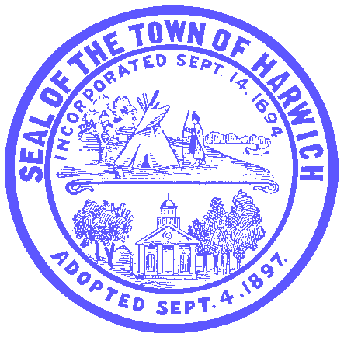

OFFICE OF THE TOWN ADMINISTRATOR Fax (508) 432-5039

Joseph F. Powers, Interim Town Administrator 732 MAIN STREET, HARWICH, MA 02645

HARWICH COVID-19 GUIDANCE DOCUMENT #11

REDUCED OPERATIONAL CAPACITY EXTENDED

FRIDAY, APRIL 17, 2020

NOTICE TO THE GENERAL PUBLIC:

This document is a follow-up to Guidance Document #10 which was released last Friday, April 10, 2020. Given that Governor Baker has confirmed that the Commonwealth of Massachusetts is in the midst of a surge in COVID-19 cases, hospitalizations, and sadly, fatalities, it is necessary to continue at reduced operational capacity.

As such, the Town of Harwich will continue with reduced government operational capacity for the week of April 20, 2020 with the noted exceptions outlined below. We will also reassess our operational capacity based on the state of the Commonwealth on April 22, 2020 to inform our decision-making going beyond April 27, 2020.

We are resuming the following government services as they have been deemed essential services by Governor Baker:

- Effective Monday, April 20, 2020, the Transfer Station for the Town of Harwich will resume all services including the collection of yard waste, manure and construction material and debris. The current traffic schematic will be extended throughout the Transfer Station property to effect social distancing. Anyone accessing the Transfer Station is urged to take all safety precautions including wearing face coverings for the protection of all; and
- Effective Tuesday, April 21, 2020, the Town of Harwich will resume remote inspectional services related to essential construction projects.

We also take this opportunity to remind the public that, given that Monday, April 20, 2020 is a recognized state holiday (Patriots Day), all municipal departments with the exception of public safety and the Transfer Station will be closed. This holiday is a timely opportunity for all of our town employees to take a much needed break from their exceptional efforts during this unprecedented public health crisis.

Thank you for your patience, cooperation and understanding as we all work through this crisis on a day by day basis with the hope of being able to resume our daily lives as soon and as safely as possible.

Respectfully submitted,

Joseph F. Powers Meggan M. Eldredge
Interim Town Administrator Health Director

