TOWN OF 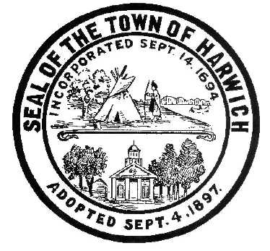 HARWICH
732 Main Street
Harwich, MA 02645
(508)-430-7538 FAX (508)430-7531
HARWICH CONSERVATION COMMISSION – MINUTES
THURSDAY – OCTOBER 13, 2022 – 10:00 AM
On-Site Meeting at 16 Olde Coach Lane
Commissioners and Staff Present: James Atkinson, Mark Coleman, John Ketchum, Alternate Member Stanley Pastuszak, and Assistant Conservation Agent Melyssa Millett
Representatives Present: Attorney Michele Hunton, Homeowner Natalia Wallace
Call to Order:
Vice Chair, John Ketchum, called the meeting to order at 9:55 AM.
Assistant Conservation Agent Melyssa Millett read the violations listed in the enforcement letter, and explained that she and Conservation Administrator Amy Usowski had been allowed onto the property by Natalia Wallace, homeowner, on August 29, 2022, following a report from a concerned neighbor of activity within the pond and buffer zone. The violations listed included installation of a deck underneath second story deck, where there previously had just been crushed stone for drainage; installation of new landscape timbers; installation of stone and mulch in area that was previously natural; removal of vegetation and sediment from near-shore area of Grass Pond; creation of a seating area with fire pit within the buffer zone to the wetland.
Commission Members stated concerns regarding the ground level deck, the loose stone on the steep section of the bank, the mulch and stone which was covering native vegetation, an electrical outlet that looked to be newly installed, two sheds on the property that looked to be relatively new, and the removal of pond sediment and possible disturbance of pond vegetation. Ms. Millett stated that there was evidence that the sheds had been installed before the property was owned by Ms. Wallace, and that some of the landscape timbers that had been installed had likely existed previously, but not all. Mr. Ketchum noted some cutting of vegetation on the bank which seemed very recent, and asked if past photos from the pond looking up the bank available, to which Ms. Millett were responded that there were not. Attorney Hunton and Ms. Wallace noted that no vegetation was removed from the property. Mr. Coleman noted a dock on the adjacent property.
Vice Chair, John Ketchum, called for the meeting to adjourn. Seconded by Jim Atkinson. Meeting adjourned at 10:20 AM.
Respectfully Submitted,
Melyssa Millett
Approved: 11/2/2022

