2019 Review, and a Vision for 2020 and Beyond
2019 continued our strong trend in membership recruitment and retention as per graph.

Harwich | 763
Chatham | 185
Eastham/Orleans | 41
Non Resident | 19
Junior | 81
Young Adult | 60

Total Membership – 1149

Despite the challenges associated with the Tornado revenue has also continued to be vigorous throughout late summer and the Fall Development of the “shoulder season” market has been very successful. We continue to match revenues and expenses on behalf of the Town in a fiscally responsible way.
Golf Expense and Revenue
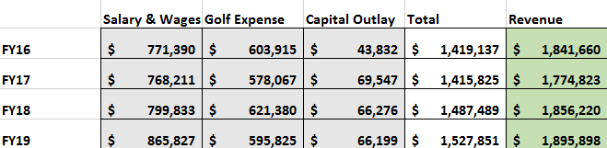

Committee participation and involvement was strong throughout the year. This year’s members are: Martha Duffy, Vice Chair, Tom Johnson, John Crook, Jack Connely, John Wheeler, and Steve Bilotta. These individual collectively bring a positive business foundation to the operations in assistance to our Director of Golf, Roman Greer and our Superintendent, Shawn Fernandez. Policies and direction given in conjunction with our management team continues to map out a vision for the future of Harwich Golf.

Major initiatives for the committee continue to be:
Completion of our capital project which will feature a ‘Solar Component”, and the introduction of “electric golf carts”, as well as final landscaping
Cost containment, and adherence to budget parameters to complete this project as approved by Town Meeting. Town Administrator Chris Clark deserves much of the credit in this endeavor.
Continued removal of tree canopy which proved significant in mitigating Tornado damage.
Cart path renewal and improvements
Club house and restaurant upgrades, the funding of these improvements will result in a “turnkey” operation as we go forward
USGA involvement in association with Committee recommendations, planning, and implementation
Robust capital projects, as endorsed by Capital Outlay which will be funded fully through golf funding mechanisms. The immediate focus in 2021, as an example, will start with our upgrading of water resource management (Irrigation) capabilities. Once again, this approach will save money in a profound way, by staying ahead of replacement needs.
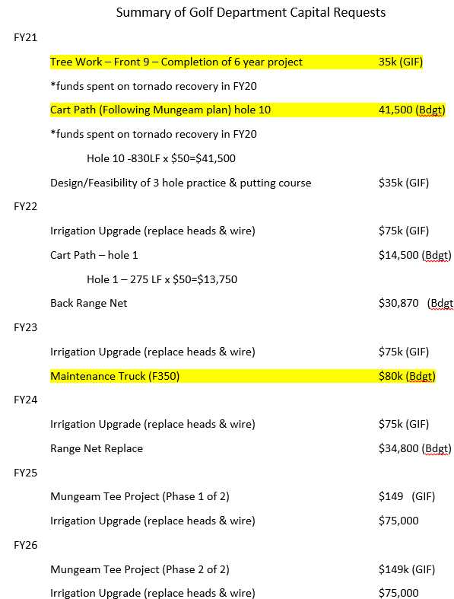

Finally, development of Junior Golf strategies to attract the next generation of Harwich golfers is a work in progress. We are in the planning stages of developing a “Junior 3-Hole” practice course along with a stadium type “Putting Complex”. These endeavors continue to be in close association with our regional High School and Middle school physical education programs. The announcement of our “First Tee” affiliation as a regional center for Junior Golf is noteworthy. Nationally our involvement and support of the “Drive Chip & Putt” competition means that someone male or female can make it all the way to Augusta. MIAA, sponsoring of State Wide Junior competitions all contribute to our vision.
In conclusion, we also have the pleasure to announce that our Director of Golf, Roman Greer, was honored with being designated as “PGA” golf professional of the year in our local Chapter. He would be the first to say he could not have accomplished this without the able core staff of: Dick Fagan, Mike Serijan, and Shawn Fernandez (Superintendent of the Green).

Respectfully submitted,
Clement Smith, Chair HGC

