TOWN OF 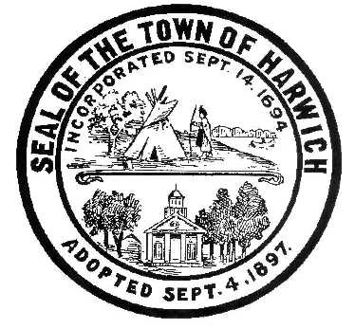 HARWICH
732 Main Street
Harwich, MA 02645
CONSERVATION COMMISSION (508)-430-7538 FAX (508)430-7531

HARWICH CONSERVATION COMMISSION – AGENDA
WEDNESDAY, NOVEMBER 1, 2017
DONN B. GRIFFIN ROOM, HARWICH TOWN HALL
6:30 PM

CALL TO ORDER
All hearings shall be subject to discussion, taking of testimony, review of submitted documents which may result in a vote being taken to approve or deny a project; or to issue a continuance to a time and date certain, in order to receive and review further information as needed. This meeting is being recorded. If any member of the audience is also recording the meeting, they must let the Chair know now.

HEARINGS

Request for Determination of Applicability:

Virginia Chamberlain, 87 Route 28, Map 10 Parcel W-3. The proposed lifting of the existing dwelling and installation of a new foundation. Work will take place in Flood Zone AE (El 11).

Roseanne Howard, 92 Belmont Road, Map 3 Parcel T1-B. The proposed is Title-5 septic system work only. This septic upgrade project is proposed to replace the existing cesspool system. The existing system is to be pumped & removed. There are no additions or alterations proposed to the dwelling.

Harwich Ecumenical Council for the Homeless Inc., 93 & 97 Main Street (Route 28), Map 10 Parcel W5 & W3-B. Remove Portion of multifamily dwelling and construct addition to the rear (#93); small portion of road construction; septic system upgrades for #93. & #97.

Notices of Intent:

David & Evelyn Grainger, 21 Uncle Venies Road, Map 17 Parcel R1-0.
SE 32-2307. Demolition of existing dwelling & tight tank. Construction of a new dwelling & tight tank within land subject to coastal storm flowage & within buffer zone to a salt marsh. (Continued from September 20, 2017)

The following applicant has filed a Extension Permit for Order of Conditions

Anne K. Helgren & Michael F. Gilligan, 74 Uncle Venies Road, Map 25 Parcel U722546. SE 32-1927. The 1 year extension is needed so the mitigation planting can be done during the growing season.

Order of Conditions:

Steven & Joanne Churchill, 17 Shore Drive, Map 78 Parcel B15. SE 32-2308.

Mark McKenney, 44 Smith Street, Map 19, Parcel A5. SE 32-2309.

Minutes-Minutes shall be subject to review, discussion, editing for suggested changes and/or deletions, and a vote shall be taken for acceptance and approval.
August 16, 2017.

Discussion and possible vote:
Cranberry Valley Golf Course 183 Oak Street
2079 Route 28
49 Lovers Lane
597 Depot Street
15 Cora Lane
Changes to the Harwich Wetlands Protection Regulations

ANY OTHER BUSINESS WHICH MAY COME BEFORE THE COMMISSION
Per the Attorney General’s Office: The committee may hold an open session for topics not reasonably anticipated by the Chair 48 hours in advance of the meeting following “New Business.” If you are deaf or hard of hearing or a person with a disability who requires an accommodation, contact the Selectmen’s Office at
508-430-7513

Authorized posting officer: Posted by:
Town Clerk
Patty Zingarelli
Signature
Date:

