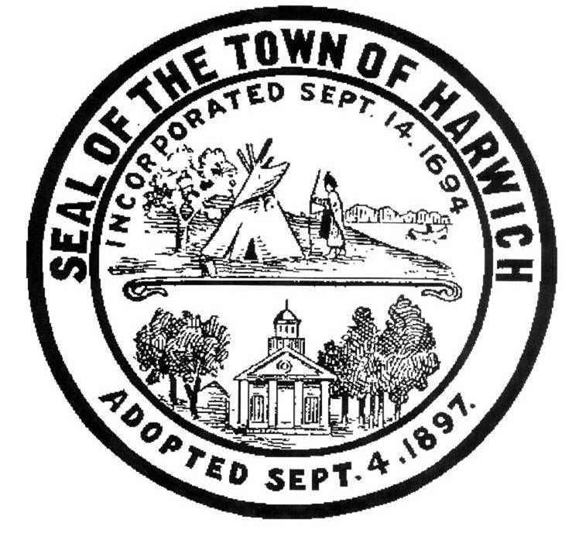Town of Harwich
ZONING BOARD OF APPEALS
732 Main Street, Harwich, MA 02645
tel: 508-430-7506 fax: 508-430-4703

ZONING BOARD of APPEALS PUBLIC HEARING
Thursday, March 10, 2016 at 7:00 p.m.
SMALL MEETING ROOM, Harwich Town Hall

AGENDA
On Thursday, March 10, 2016 at 7:00 PM, the Harwich Zoning Board of Appeals will hold a Public Hearing in the SMALL Meeting Room at the Harwich Town Hall, 732 Main Street to hear the following CONTINUED case.

Case #2016-03 (CONTINUED from 2/24/16)

Mark H. Carter and Samantha D. Carter, by their attorney, William D. Crowell, Esq. have applied for a Special Permit to construct an Accessory Building (a two-car garage), Residential With Bedrooms consisting of a two-car garage with two bedrooms and two baths above. The Petitioners also seek a Variance from the easterly boundary of their lot. The application is pursuant to the Code of the Town of Harwich §325 Table 2, Area Regulations, §325 Table 1,
Line 1b, Use Regulations and §325-52 Variances as set forth in MGL Chapter 40A, §6 and §10. The property is located at 25 Cottage Ave, Map 6, Parcel G2-6 in the RH 1 Zoning District.

Documents related to the above case are on file with the Building Department and the Office of the Town Clerk located at 732 Main Street, Harwich and may be viewed during regular department business hours.

Per the Attorney General’s Office: The Board may hold an open session for topics not reasonably anticipated by the Chair 48 hours in advance of the meeting following “New Business.” If you are deaf or hard of hearing or a person with a disability who requires an accommodation, please contact the Selectmen’s Office at
508-430-7513

This Agenda may change at the discretion of the Board.

Recording & Taping Notification: As required by law, the Town may audio or video record this meeting. Any person intending to either audio or video record this open session is required to inform the chair.
Authorized Posting Officer: Shelagh Delaney, sdelaney@town.harwich.ma.us
Board of Appeals Recording Clerk

