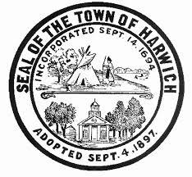
Town of Harwich
COUNCIL ON AGING BOARD MEETING
Room #1
Harwich Community Center  100 Oak Street  Harwich, MA
Wednesday, October 4, 2017, 10:00 am

AGENDA

Call to Order

Approval of Minutes
- Approval of Minutes from the July 5, 2017 and September 13, 2017 COA Board of Directors Meetings (VOTE REQUIRED)

Public Comment

Chair’s Report
- Review of Board vacancy
- Annual Report to BOS

Director’s Report (Judi Wilson)

Old Business

New Business
- Review Draft COA Confidentiality Policy (VOTE REQUIRED)
- Review Draft COA CORI Policy (VOTE REQUIRED)

Adjournment

REMINDER: Next HCOA Board Meeting – Wednesday, November 1, 2017, 10:00am

Authorized Posting Officer: Posted by: __________________________
Town Clerk

Richard J. Waystack Date: September 29, 2017
Signature, Chairman, Council on Aging

