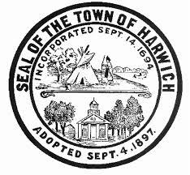
Town of Harwich
COUNCIL ON AGING BOARD MEETING
Room #1
Harwich Community Center  100 Oak Street  Harwich, MA
Wednesday, March 7, 2018, 10:00 am

AGENDA

Call to Order

Approval of Minutes
- Approval of Minutes from the January 10, 2018 COA Board of Directors Meetings (VOTE REQUIRED)**

Public Comment

Chair’s Comments

Director’s Report (Judi Wilson)**
- FY19 Budget Update
- Monthly Update
- Transition & My Senior Center Report

Old Business
- Discuss and Review Mission of COA**

New Business

Adjournment

**Supporting information available at the Harwich Council on Aging

REMINDER: Next HCOA Board Meeting – Wednesday, April 4, 2018, 10:00am

Authorized Posting Officer: Posted by: __________________________
Town Clerk

Judi Wilson Date: March 5, 2018
Signature, Director, Council on Aging

