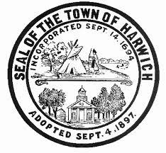
Town of Harwich
COUNCIL ON AGING BOARD MEETING
Room #1
Harwich Community Center  100 Oak Street  Harwich, MA
Wednesday, May 2, 2018, 10:00 am

AGENDA

Call to Order

Approval of Minutes
- Approval of Minutes from the April 4, 2018 COA Board of Directors Meetings (VOTE REQUIRED)**

Public Comment

Chair’s Comments

Director’s Report (Judi Wilson)**
- Monthly Update
- Transition & My Senior Center Update

Old Business
- Discuss and Review Mission of COA (VOTE REQUIRED)**
- Elder Services Board of Directors

New Business
- New CCRTA Leased Vehicle
- Discussion of staffing needs

Adjournment

**Supporting information available at the Harwich Council on Aging

REMINDER: Next HCOA Board Meeting – Wednesday, June 6, 2018, 10:00am

Authorized Posting Officer: Posted by: __________________________
Town Clerk

Judi Wilson Date: April 30, 2018
Signature, Director, Council on Aging

