TOWN OF 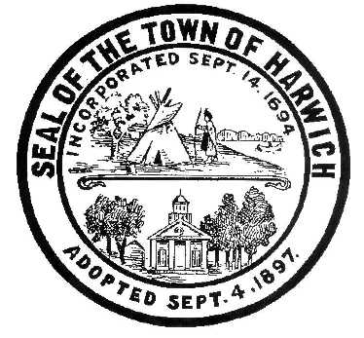 HARWICH

732 Main Street
Harwich, MA 02645
CONSERVATION COMMISSION (508)-430-7538 FAX (508)430-7531

HARWICH CONSERVATION COMMISSION – AGENDA
WEDNESDAY, DECEMBER 20, 2017
6:30 P.M.
SMALL HEARING ROOM, HARWICH TOWN HALL
Revised 12/8/2017, 11:55am
CALL TO ORDER
HEARINGS
All hearings shall be subject to discussion, taking of testimony, review of submitted and documents which may result in a vote being taken to approve or deny a project; or to issue a continuance to a time and date certain in order to receive and review further information as needed.
The following applicants have filed a Request for Determination of Applicability:

Town of Harwich Department of Public Works, Lower County Road Bridge over Herring River. Repair of bridge. Saw-cutting of road and installation of t-base then repaving. Installation of filter fabric on eroded bank.
The following applicants have filed a Notice of Intent:

The Tide River Nominee Trust, Lawrence Damon, Trustee, 44 Chase Street, Map 4, Parcel N1-D2. Proposed construction of a swimming pool, pool shed, fence and relocation of existing drive.

Andrew and Katie Hutton, 437 Route 28, Map 13, Parcel S1-B3. Replacement of the original sewage system with a Title 5 sewage system. No expansion of the existing building is proposed.

Discussion
Possible conversion of carport to garage at 130 Forest Street
Fence and other activities in buffer zone at 14 Riverbend
Construction at 177 Forest Street that has exceeded permit
Lease language for the Bells Neck Cranberry Bogs

Orders of Conditions
The CDW Realty Trust, Janice Salvadore, 14 Rainbow Way, Map 73 Parcel S153.
Kevin Blute, 62 Clearwater Drive, Map 72 Parcel W86.
Wayne and Susan Pratt, 22 Walkerwoods Drive, Map 94 Parcel A5-8.

Request for Certificate of Compliance
David Tourigny – 4 Chase Street – DEP SE 32-2243

Minutes vote shall be taken
Minutes shall be subject to review, discussion, editing for suggested changes and/or deletions, and a vote shall be taken for acceptance and approval.
October 18, 2017 and November 1, 2017
ANY OTHER BUSINESS WHICH MAY COME BEFORE THE COMMISSION
Per the Attorney General’s Office: The committee may hold an open session for topics not reasonably anticipated by the Chair 48 hours in advance of the meeting following “New Business.” If you are deaf or hard of hearing or a person with a disability who requires an accommodation, contact the Selectmen’s Office at
508-430-7513

Authorized posting officer: Posted by:
Town Clerk
Amy Usowski 12/8/2017
Signature
Date:

