**TOWN *OF*** *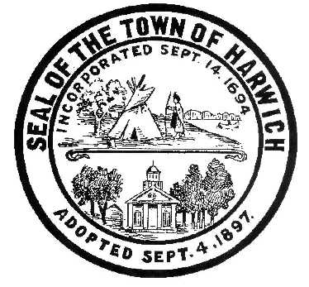* ***HARWICH***

***HARWICH ACCESSIBILITY RIGHTS COMMITTEE***

***Harwich Town Hall Small Conference Room***

***Thursday, April 26, 2018 6:30 PM***

***MINUTES***

Meeting Called to Order: 6:30 pm

Attendance & Introductions:

MINUTES: Review & Approval of March 22, 2018 Meeting Minutes

OPEN FORUM:

OLD BUSINESS:

1. Update on status of ADA Self Evaluation Consulting Project
2. Introduction Plans of Consultant to Municipal Buildings

NEW BUSINESS:

1. Update on damaged ADA Certified Dock Ramp at Saquatucket
2. Update on Wixon Dock ADA Access and Parking Plans
3. Town of Harwich “How to develop an ADA Self-Evaluation

& Transition Plan” now on Channel 18

MONTHLY REPORTS:

CORRESPONDANCE:

NEXT MEETING: Thursday, 2018

ADJOURNMENT:

Posting Date: W. Matthew Hart, Chairman Matt's Signature2_Pic1

*The committee may hold an open session for topics not reasonably anticipated by the Chair 48 hours in advance of the meeting following “New Business.” If you are deaf or hard of hearing or a person with a disability who requires an accommodation, contact the Selectmen’s Office at 508-430-7513***.**