**TOWN *OF*** *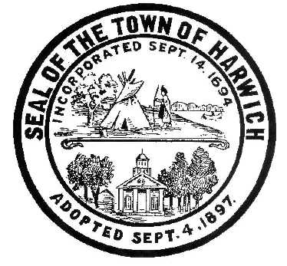* ***HARWICH***

***HARWICH ACCESSIBILITY RIGHTS COMMITTEE***

***Harwich Town Hall Small Conference Room***

***Thursday, December 28, 2017 6:30 PM***

***AGENDA***

Attendance and Introductions:

MINUTES: Review & Approval

OPEN FORUM:

OLD BUSINESS:

1. Progress with ADA (MOD) Infrastructure Grant request (Saquatucket Landside)
2. Progress with ADA (MOD) Planning Grant request (Harwich Self Evaluation Consultant)
3. Chairman’s Annual Report to BOS Dec. 11, 2017

NEW BUSINESS:

1. Updating the HARC Mission Statement (Gary’s add-on)
2. Request from Pleasant Bay Community Boating for letter of endorsing new dock

(moved to Jan. 2018) Copy included.

1. Discussion and potential Grant Request to IBM for ADA Communication Access

IBM Grant Information

The primary focus of our corporate citizenship activities is on developing initiatives to address specific societal issues, such as the environment, community economic development, education, health, literacy, language and culture. We employ IBM's most valuable resources, our technology and talent, in order to create innovative programs in these areas to assist communities around the world.

These resources are allocated to specific projects and programs that fit within our targeted areas of interest. The overwhelming majority of our activities are proactively initiated by IBM, and is not a result of unsolicited proposals. We do not encourage unsolicited proposals. Please note the following guidelines.

IBM partners with organizations which have a tax-exempt classification under Sections 170(c) or 501(c)(3) of the U.S. Internal Revenue Code. We do not make product and services donations or grants to:

* Individuals, political, labor, religious, or fraternal organizations or sports groups;
* Fundraising events such as raffles, telethons, walk-a-thons or auctions;
* Capital campaigns, construction and renovation projects;
* Chairs, endowments or scholarships sponsored by academic or nonprofit institutions;
* Special events such as conferences, symposia or sports competitions;
* Organizations that advocate, support, or practice activities inconsistent with IBM's non-discrimination policies, whether based on race, color, religion, gender, gender identity or expression, sexual orientation, national origin, disability, age or status as a protected veteran.

MONTHLY REPORTS:

Board of Selectmen:

Voted for change of committee’s name to Harwich Accessibility Rights Committee.

CORRESPONDANCE:

NEXT MEETING:

ADJOURNMENT:

Posting Date: W. Matthew Hart, Chairman Matt's Signature2_Pic1

*The committee may hold an open session for topics not reasonably anticipated by the Chair 48 hours in advance of the meeting following “New Business.” If you are deaf or hard of hearing or a person with a disability who requires an accommodation, contact the Selectmen’s Office at 508-430-7513***.**