**TOWN *OF*** *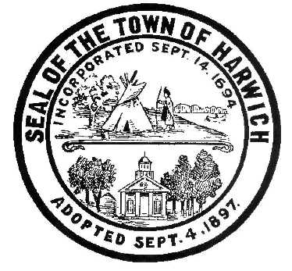* ***HARWICH***

***HARWICH ACCESSIBILITY RIGHTS COMMITTEE***

***Harwich Town Hall Small Conference Room***

***Thursday, February 22, 2017 6:30 PM***

***AGENDA***

Attendance and Introductions:

MINUTES: Review & Approval

OPEN FORUM:

OLD BUSINESS:

1. ADA Self-Evaluation Grant approval (Harwich Self Evaluation Consultant)

NEW BUSINESS:

1. Conflict of Interest Law for Municipal Employees review and signing (Gary)
2. Final RFP for Self-Evaluation Project & Transition (Meeting with Chris Clark Feb 20th)
3. Continued Discussion about potential Grant Request to IBM for Communication Access

MONTHLY REPORTS:

Board of Selectmen:

Voted for change of committee’s name to Harwich Accessibility Rights Committee.

CORRESPONDANCE:

NEXT MEETING: March 22, 2018

ADJOURNMENT:

Posting Date: February 14, 2018 W. Matthew Hart, Chairman Matt's Signature2_Pic1

*The committee may hold an open session for topics not reasonably anticipated by the Chair 48 hours in advance of the meeting following “New Business.” If you are deaf or hard of hearing or a person with a disability who requires an accommodation, contact the Selectmen’s Office at 508-430-7513***.**