**TOWN *OF*** *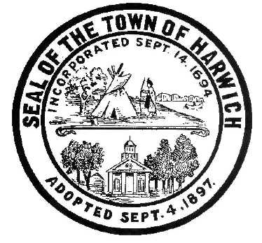* ***HARWICH***

***HARWICH ACCESSIBILITY RIGHTS COMMITTEE***

***Harwich Town Hall Small Conference Room***

***Thursday, July 26, 2018 6:30 PM***

***AGENDA***

***THE NORMALLY SCHEDULED MEETING FOR JULY HAS BEEN POSTPONED UNTIL SEPTEMBER BECAUSE THE FINAL RESULTS OF HARWICH ADA SELF-EVALUATION WILL NOT BE AVAILABLE FOR PUBLIC REVIEWS AND COMMENTS UNTIL THE SEPTEMBER 2018***

Attendance and Introductions:

MINUTES: Review & Approval

OPEN FORUM:

OLD BUSINESS:

NEW BUSINESS:

MONTHLY REPORTS:

Board of Selectmen

CORRESPONDANCE:

NEXT MEETING: THURSDAY SEPTEMBER 27. 2018

ADJOURNMENT:

Posting Date: W. Matthew Hart, Chairman Matt's Signature2_Pic1

*The committee may hold an open session for topics not reasonably anticipated by the Chair 48 hours in advance of the meeting following “New Business.” If you are deaf or hard of hearing or a person with a disability who requires an accommodation, contact the Selectmen’s Office at 508-430-7513***.**