**TOWN *OF*** *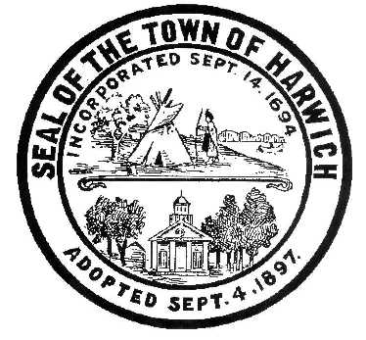* ***HARWICH***

***HARWICH ACCESSIBILITY RIGHTS COMMITTEE***

***Harwich Town Hall Small Conference Room***

***Thursday, March 29, 2017 6:30 PM***

***AGENDA***

***PLEASE NOTE THAT THE HARC MEETING WAS MOVED TO THE LAST THURSDAY IN MARCH TO ALLOW FOR THE ADA SELF ANALYSIS BIDS TO BE SORTED OUT ON MARCH 22, 2018***

Attendance and Introductions:

MINUTES: Review & Approval

OPEN FORUM:

OLD BUSINESS:

1. Update of Conflict of Interest Signature

NEW BUSINESS:

1. Review and update of ADA Self Analysis Bids

MONTHLY REPORTS:

Board of Selectmen

CORRESPONDANCE:

Receipt of RFP Bids for ADA Self Analysis (end of workday March 22, 2018)

NEXT MEETING:

Thursday April19, 2018

ADJOURNMENT:

Posting Date: 03/22/2018 W. Matthew Hart, Chairman Matt's Signature2_Pic1

*The committee may hold an open session for topics not reasonably anticipated by the Chair 48 hours in advance of the meeting following “New Business.” If you are deaf or hard of hearing or a person with a disability who requires an accommodation, contact the Selectmen’s Office at 508-430-7513***.**