**TOWN *OF*** *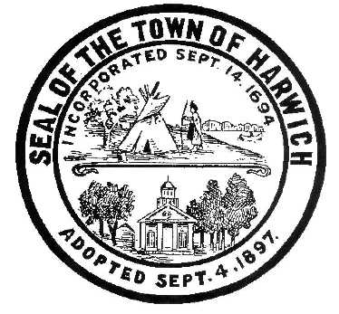* ***HARWICH***

***HARWICH ACCESSIBILITY RIGHTS COMMISSION***

***Harwich Town Hall Small Conference Room***

***Thursday November 30, 2017 6:30 PM***

***AGENDA***

Attendance and Introductions:

MINUTES: Review & Approval

OPEN FORUM: (Topics not listed on Agenda but of interest and importance to committee)

OLD BUSINESS:

1. Progress with ADA (MOD) Infrastructure Grant request (Saquatucket Landside)
2. Progress with ADA (MOD) Planning Grant request (Harwich Self Evaluation Consultant)
3. Discussion about ADA & MOD material provided in the ‘Flash Drive’ & HARC Alerts

NEW BUSINESS: (Brief discussions and recommendations on the following)

1. HARC “Mission Statement” and “What we do”
2. Review of the DRAFT Self-Evaluation Municipal Inventory document
3. Discussion and informal planning for:
4. Implementation of the future ADA (MOD) Grant process opportunities
5. ADA Coordinator? What is our next step toward an appointment by the Town
6. Continue to provide Public Notice and encourage new membership and attendees
7. Adopt a HARC Grievance Procedure and Policy
8. Prepare for the Harwich Municipal Self-Evaluation bidding and review process
9. Develop a long-range Transition Plan for the Self-Evaluation results
10. Request BOS change name to HARC (Harwich Accessibilities Rights Committee)
11. Create a Harwich Accessibilities Rights Committee Action Plan and Objectives
12. Contact Chatham, Dennis and Barnstable Disability Rights Committees to see if we can work together and share ideas and resources.
13. Inquire why there is not an ADA Employment Section of Cape Cod Times?
14. Discussions about coordinating with Harwich Veterans Agent, Elder Services and local Churches.

MONTHLY REPORTS:

Board of Selectmen,

Other Town Departments

CORRESPONDANCE:

NEXT MEETING: November 23, 2017

ADJOURNMENT:

Posting Date: October 11, 2016 W. Matthew Hart, Chairman Matt's Signature2_Pic1

*The committee may hold an open session for topics not reasonably anticipated by the Chair 48 hours in advance of the meeting following “New Business.” If you are deaf or hard of hearing or a person with a disability who requires an accommodation, contact the Selectmen’s Office at 508-430-7513***.**