TOWN OF 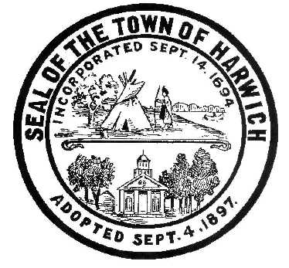 HARWICH
HARWICH ACCESSIBILITY RIGHTS COMMISSION
Harwich Town Hall Small Conference Room
Thursday, , 2017 6:30 PM
AGENDA
Verification of Harwich Committee Oath and Current MA Ethics Training requirements

Attendance and Introductions:

MINUTES: Review & Approval

OPEN FORUM:

OLD BUSINESS:

NEW BUSINESS:

MONTHLY REPORTS:
Board of Selectmen

CORRESPONDANCE:

NEXT MEETING:

ADJOURNMENT:

Posting Date:

The committee may hold an open session for topics not reasonably anticipated by the Chair 48 hours in advance of the meeting following “New Business.” If you are deaf or hard of hearing or a person with a disability who requires an accommodation, contact the Selectmen’s Office at 508-430-7513.

