TOWN OF 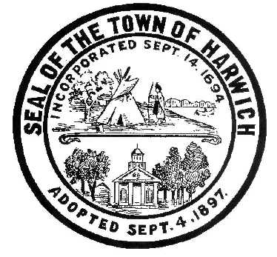 HARWICH

732 Main Street
Harwich, MA 02645
CONSERVATION COMMISSION (508)-430-7538 FAX (508)430-7531
HARWICH CONSERVATION COMMISSION – AGENDA
WEDNESDAY, JANUARY 17, 2018
6:30 P.M.
SMALL HEARING ROOM, HARWICH TOWN HALL
CALL TO ORDER
HEARINGS
All hearings shall be subject to discussion, taking of testimony, review of submitted and documents which may result in a vote being taken to approve or deny a project; or to issue a continuance to a time and date certain in order to receive and review further information as needed.
The following applicants have filed a Request for Determination of Applicability:

Outer Cape Health Services, 710 Main St (Route 28), Harwich Port, Map 15 Parcel K2. Proposed work includes implementing flood-proofing measures, reconstructing parking and walkways to be ADA compliant. Installation or re-construction of curbing, sidewalks and stoops. Removal of a paved loading dock to allow for an enclosed trash storage area and ambulance loading zone. The site lies within the FEMA AE 11’ flood zone.
The following applicants have filed a Notice of Intent:

Demetrios Dasco, 23-1 Snow Inn Road, Unit 1, Wychmere Shores Condos, Map 8 Parcel P2-1. Proposed patio extension and outdoor kitchen, replacement of brick patio with cut stone patio and mitigation plantings. Work will take place within the 50’ buffer zone to the top of coastal bank and in the flood zone. (Continued from Sept 20, 2017)

Ruthanne and David Schoetz, 10 Spring Tide Lane, Map 38, Parcel A1-5. Vista pruning, 4 ft. wide path, invasive plant removal and planting of native shrubs in a 3:1 ratio. (Continued from 1/3/2018)

Paul Norton, 68 Smith Street, Map 19, Parcel A9-2. Construction of a 24’x30’ garage and driveway extension. (Continued from 1/3/2018)

Luiza A. Beaupre, 9 Herring Run Road, Map 36 Parcel L11. The proposed additions/renovations to an existing structure and installation of a Title 5 septic system. Work will take place in the 100’ buffer to a coastal bank and in riverfront area.

Joshua and Jason Michniewicz, 45 Main Street, Map 55 Parcel H2-1. Proposed site development for a 6,000 sq. ft. industrial building within 100’ of an isolated freshwater wetland.

Discussion and Possible Vote
Lease of the Bells Neck Cranberry Bogs

Orders of Conditions
Jeffrey Kevin Joyce and Marilyn Heaney Joyce, Trustees, 22 Harwich Pines, Map 103, Parcel SE1-14. Proposed licensing and maintaining of a seasonal dock.

James Killian, 5 Weeks Road, Map 16, Parcel N1-24. Removal of 45 trees and replant with 120 plantings. Disturbed area will be scraped, loamed and seeded with Harmony Seed Mix in buffer zone. Removal of creosote timbers along the driveway and replacement with cobblestone. Creosote retaining wall and staircases will be removed and replaced with NE fieldstone wall and bluestone steps. Annual vista pruning.

Certificates of Compliance

Rosemary and Christine Gregorski, 33 Nons Road, Map 5, Parcel W117. Bank stabilization and revetment return extension.

Thomas Morrison, 4 Fiddler’s Landing, Map 13, Parcel R4. Landscaping and exterior site improvements; control vegetation on coastal bank.

Minutes vote shall be taken
Minutes shall be subject to review, discussion, editing for suggested changes and/or deletions, and a vote shall be taken for acceptance and approval.
October 18, 2017, November 1, 2017, December 6, 2017
ANY OTHER BUSINESS WHICH MAY COME BEFORE THE COMMISSION
Per the Attorney General’s Office: The committee may hold an open session for topics not reasonably anticipated by the Chair 48 hours in advance of the meeting following “New Business.” If you are deaf or hard of hearing or a person with a disability who requires an accommodation, contact the Selectmen’s Office at
508-430-7513
Authorized posting officer: Posted by:
Town Clerk
Amy Usowski
Signature
Date:

