TOWN OF 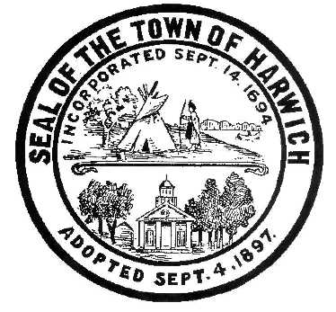 HARWICH
WATERWAYS COMMITTEE
Harwich Fire Station Conference Room
Wednesday August 16, 2017 6:30 PM AGENDA

Verification of Harwich Committee’s Oath and Current MA Ethics Training requirements

Attendance and Introductions:

MINUTES: Review & Approval

OPEN FORUM:

FINANCIAL REPORT YTD & Monthly

OLD BUSINESS:
- Election of Chairman and Vice Chairman of WWC for FY 2018
- Update and progress with Landside Bid process
- Update and progress with Waterside Permits and resulting Bid process
- Status of Corps of Engineers permit and regulation process

NEW BUSINESS:
- Discussions and vote on Harbormaster Fees in anticipation of BOS review

MONTHLY REPORTS:
Board of Selectmen
Harbormaster
Natural Resource Officer

CORRESPONDANCE:

NEXT MEETING: Sept. 20, 2017

ADJOURNMENT:

Posting Date:

The committee may hold an open session for topics not reasonably anticipated by the Chair 48 hours in advance of the meeting following “New Business.” If you are deaf or hard of hearing or a person with a disability who requires an accommodation, contact the Selectmen’s Office at 508-430-7513.

