TOWN OF 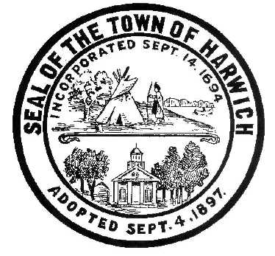 HARWICH
WATERWAYS COMMITTEE
Harwich Fire Station Conference Room
Wednesday, July 19, 2017 6:30 PM
AGENDA

Attendance and Introductions:

MINUTES: Review & Approval

CONSENT AGENDA:

OPEN FORUM:

FINANCIAL REPORT YTD & Monthly

OLD BUSINESS:
- Update and progress with Landside Bid process
- Update and progress with Waterside Permits and resulting Bid process

NEW BUSINESS:
- Reversal of previously approved HMP regulation allowing Harbormaster to rent winter storage space to individuals. By instruction of BOS.

MONTHLY REPORTS:
Board of Selectmen
Harbormaster
Natural Resource Officer

CORRESPONDANCE:

NEXT MEETING:

ADJOURNMENT:

Posting Date: Friday July 14. 2017

The committee may hold an open session for topics not reasonably anticipated by the Chair 48 hours in advance of the meeting following “New Business.” If you are deaf or hard of hearing or a person with a disability who requires an accommodation, contact the Selectmen’s Office at 508-430-7513.

