TOWN OF 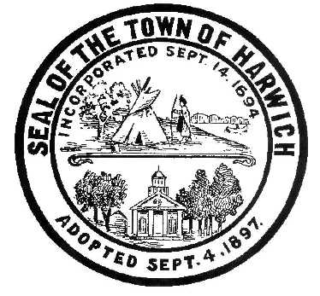 HARWICH
WATERWAYS COMMITTEE
Harwich Fire Station Conference Room
175 Sisson Road, Harwich MA 02645
Wednesday, March 15, 2017 6:30 PM
AGENDA
Attendance and Introductions:
MINUTES: Review & Approval
CONSENT AGENDA:
OPEN FORUM:
FINANCIAL REPORT YTD & Monthly

OLD BUSINESS: Updates on the progress of the Saquatucket Waterside and Landside Projects

NEW BUSINESS: Heinz Proft, Natural Resource Officer
Summary/update on the CWMP - Comprehensive Wastewater Management Plan
for the Town Harwich including a brochure/booklet hand out.

At the May 2017 WWC meeting, Heinz will be giving a summary/presentation on the current an ongoing Natural Resources projects and upcoming topics. This presentation will include the status of Herring Run, Eel migration, Water sampling program, Shellfish Lab, and the Aquaculture internship program.

MONTHLY REPORTS:
Board of Selectmen
Harbormaster
Natural Resource Officer

CORRESPONDANCE:
NEXT MEETING:
ADJOURNMENT:
Authorized Posting Officer: Posted By:
W. Matthew Hart WWC Chairman
Signed Date: March 09, 2017

The committee may hold an open session for topics not reasonably anticipated by the Chair 48 hours in advance of the meeting following “New Business.” If you are deaf or hard of hearing or a person with a disability who requires an accommodation, contact the Selectmen’s Office at 508-430-7513.

