TOWN OF 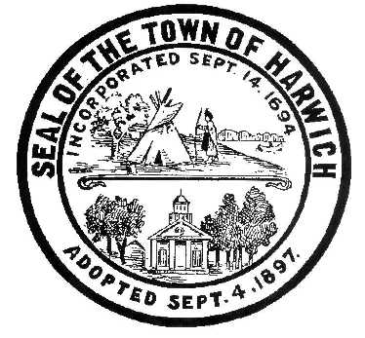 HARWICH
WATERWAYS COMMITTEE
Harwich Fire Station Conference Room
Wednesday November 15, 2017 6:30 PM
AGENDA

Attendance and Introductions:

MINUTES: Review & Approval

OPEN FORUM:

FINANCIAL REPORT YTD & Monthly

OLD BUSINESS:
- Update and progress with Landside Development progress and Bid process
- Update and progress with the Waterside Marina replacement process

NEW BUSINESS:
- Discussion about Landside Restaurant and Artist inquiries

MONTHLY REPORTS:
Board of Selectmen
Harbormaster
Natural Resource Officer

CORRESPONDANCE:

NEXT MEETING:

ADJOURNMENT:

Posting Date:
The committee may hold an open session for topics not reasonably anticipated by the Chair 48 hours in advance of the meeting following “New Business.” If you are deaf or hard of hearing or a person with a disability who requires an accommodation, contact the Selectmen’s Office at 508-430-7513.

