TOWN OF 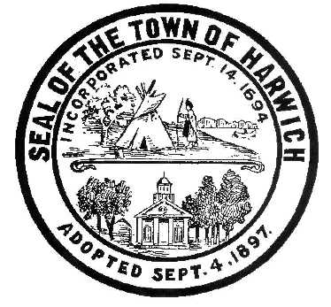 HARWICH
WATERWAYS COMMITTEE
Harwich Fire Station Conference Room
Wednesday, October 18, 2017 6:30 PM
AGENDA

Attendance and Introductions:

MINUTES: Review & Approval

OPEN FORUM:

FINANCIAL REPORT YTD & Monthly

OLD BUSINESS:
- Update and progress with Saquatucket Landside rebidding results and potential re-application at Town Meeting.
- Update and progress with Saquatucket Marina removal, dredging and replacement

NEW BUSINESS:

MONTHLY REPORTS:
Board of Selectmen
Harbormaster
Natural Resource Officer

CORRESPONDANCE:

NEXT MEETING: November 15, 2017

ADJOURNMENT:

Posting Date:
The committee may hold an open session for topics not reasonably anticipated by the Chair 48 hours in advance of the meeting following “New Business.” If you are deaf or hard of hearing or a person with a disability who requires an accommodation, contact the Selectmen’s Office at 508-430-7513.

