TOWN OF 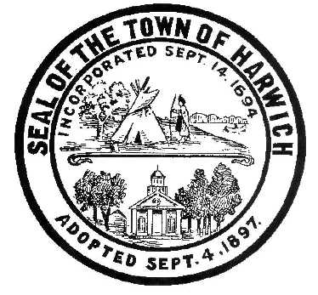 HARWICH
WATERWAYS COMMITTEE
Harwich Fire Station Conference Room
Wednesday, September 20, 2017 6:30 PM
AGENDA
Verification of Harwich Committee Oath and Current MA Ethics Training requirements

Attendance and Introductions:

MINUTES: Review & Approval

OPEN FORUM:

FINANCIAL REPORT YTD & Monthly

OLD BUSINESS:
- Results of the Dock and Mooring related fees Hearing with BOS

NEW BUSINESS:
- Update on the bid process and progress with Landside Bid
- Update and progress with Waterside Disassembly, Dredging and Construction process

MONTHLY REPORTS:
Board of Selectmen
Harbormaster
Natural Resource Officer

CORRESPONDANCE:

NEXT MEETING: Wednesday October 18, 2017

ADJOURNMENT:

Posting Date: September 13, 2017

The committee may hold an open session for topics not reasonably anticipated by the Chair 48 hours in advance of the meeting following “New Business.” If you are deaf or hard of hearing or a person with a disability who requires an accommodation, contact the Selectmen’s Office at 508-430-7513.

