TOWN OF 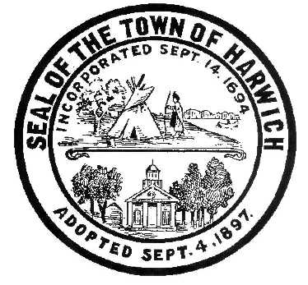 HARWICH
732 Main Street
Harwich, MA 02645
PHONE (508)-430-7538 FAX (508)430-7531
HARWICH CONSERVATION COMMISSION - MEETING AGENDA
TOWN HALL - GRIFFIN ROOM
WEDNESDAY – APRIL 5, 2023 – 6:30 PM

*Public may attend the meeting in person, access the meeting on Channel 18 (Broadcasting Live), or can login to the meeting remotely using the following login information*
Please join my meeting from your computer, tablet or smartphone.
https://meet.goto.com/534180429

You can also dial in using your phone.
Access Code: 534-180-429

United States: +1 (224) 501-3412

New to GoToMeeting? Download the App here: https://meet.goto.com/install

6:30 PM HEARINGS
All hearings shall be subject to discussion, taking of testimony, review of submitted and documents which may result in a vote being taken to approve or deny a project; or to issue a continuance to a time and date certain to receive and review further information as needed.
The following applicants have requested a Determination of Applicability

Rebecca Brack, 166 Headwaters Dr, Map 80 Parcel K65. Stabilize Bank and Replace Stair Components.

LISCOCAPE LLC, 10 Fiddlers Landing, Map 6 Parcel A1-10. Remove Portion of Existing Dwelling and Replace with New Addition.

The following applicants have filed a Notice of Intent

Peter Van Dyck & Ann Foster, 5 Panorama Point Dr, Map 91 Parcel G2-7. Construct Access Stairs and Seasonal Dock.

Thomas and Gina Flannery, 58 Chase St, Map 4 Parcel E2-B. Replace Bulkhead.

Brendan and Michelle Glynn, 20 Brooks Rd, Map 5 Parcel K1-A5. Construct Pool and Hardscape.
Natalia Wallace, 16 Olde Coach Ln, Map 112 Parcel A6-28. After-the-fact Application to Permit a Deck and Restoration Plan.

Michelle Marie Mann Abel, 18 Bob White Ln, Map 17 Parcel G4. Raze and Replace Single-Family Dwelling and Appurtenances.

Discussion and Possible Vote:
Update of Harwich Wetlands Protection Regulations

Update on ongoing land management tasks:
Herring River Study

Change to May meeting schedule and filing deadlines

Minutes
November 16, 2022
December 7, 2022
December 21, 2022
March 31, 2023 On-Site

ANY OTHER BUSINESS WHICH MAY COME BEFORE THE COMMISSION
Authorized posting officer: Posted by: Town Clerk
Melyssa Millett
Signature Date:

