TOWN OF 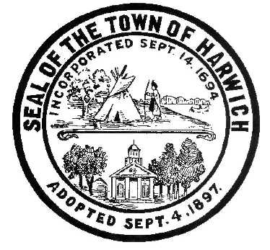 HARWICH
732 Main Street
Harwich, MA 02645
CONSERVATION COMMISSION
PHONE (508)-430-7538 FAX (508)430-7531
HARWICH CONSERVATION COMMISSION - AGENDA
TOWN HALL – GRIFFIN ROOM – HYBRID MEETING
WEDNESDAY AUGUST 17, 2022 – 6:30 PM
*Public may attend the meeting in person, access the meeting on Channel 18 (Broadcasting Live), or can login to the meeting remotely using the following login information*
Please join my meeting from your computer, tablet or smartphone.
https://meet.goto.com/914886549
You can also dial in using your phone.
United States: +1 (646) 749-3122
Access Code: 914-886-549
New to GoToMeeting? Download the App here: https://meet.goto.com/install
6:30 PM HEARINGS
All hearings shall be subject to discussion, taking of testimony, review of submitted and documents which may result in a vote being taken to approve or deny a project; or to issue a continuance to a time and date certain in order to receive and review further information as needed.
The following applicants have requested an Amended Order of Conditions
Ken Tomasian, 17 Indigo Lane, Map 80 Parcel D112. SE32-2471. Addition of a screened porch to an approved single family dwelling.
Katherine Seufert Green, 2261 Head of the Bay Rd, Map 119 Parcel N5. SE32-2425. Addition of a stone patio to an approved renovation plan.
The following applicants have filed a Notice of Intent
Donald Annino, 14 Mill Point Rd, Map 1 Parcel J1-94. Proposed Pier, Ramp, Float, and Dredging.

Orders of Conditions
Michael Lach, Harwich Conservation Trust, Cold Brook Preserve, Map 23 Parcels C3-2, C1-0, and C1-1. Proposed Ecological Restoration.

Discussion and Possible Vote
2 Harvest Hollow – Unpermitted Fence
Update on conversation with Counsel regarding the 374 Main Street property

Minutes
October 2, 2019
December 18, 2019
May 19, 2022
June 1, 2022
EXECUTIVE SESSION
July 6, 2022 Executive Session Minutes

Update and possible vote on Court Cases – 47 & 52 North Rd

ANY OTHER BUSINESS WHICH MAY COME BEFORE THE COMMISSION
Authorized posting officer: Posted by: Town Clerk
Melyssa Millett 8/12/2022 Signature Date

