TOWN OF 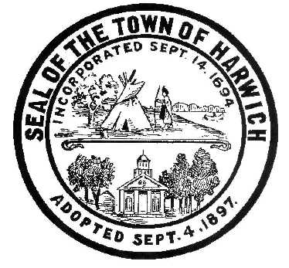 HARWICH
732 Main Street
Harwich, MA 02645

CONSERVATION COMMISSION
PHONE (508)-430-7538 FAX (508)430-7531
HARWICH CONSERVATION COMMISSION - AGENDA
AUGUST 18, 2021 6:30 PM
GRIFFIN ROOM – TOWN HALL

*Public may attend the meeting in person, access the meeting on Channel 18 (Broadcasting Live), or can login to the meeting using the following login information*

Please join my meeting from your computer, tablet or smartphone.
https://global.gotomeeting.com/join/397290741
You can also dial in using your phone.
United States: +1 (646) 749-3122
Access Code: 397-290-741

6:30 PM HEARINGS
All hearings shall be subject to discussion, taking of testimony, review of submitted and documents which may result in a vote being taken to approve or deny a project; or to issue a continuance to a time and date certain in order to receive and review further information as needed.
The following applicants have filed a Request for Determination of Applicability

Massimo Marino, 22 Uncle Venies Rd, Map 17 Parcel B4-2. Reconstruct shed, reseed disturbed area, and shrub plantings.

The following applicants have requested to Amend an Order of Conditions

Francis Zarette, 11 Harbor Way, Map 1 Parcel H3. Proposal to eliminate proposed bulkhead, rearrange and adjust scope of plantings.

The following applicants have filed a Notice of Intent

Michael and Sheila LeBlanc, 28 Wah Wah Taysee Road, Map 6 Parcel F1-12. Proposed elevated walkway and landing.

Ken Tomasian, 17 Indigo Lane, Map 80 Parcel D112. Proposed one-bedroom dwelling on a vacant lot.

William and Caroline Counselman, 5 Fiddler’s Landing, Map 6 Parcel A1-8. Demo and replace a single family dwelling and make site improvements.

Ronald and Jennifer Paasch, 7 Prince Charles Drive, Map 110 Parcel S27. After-the-fact permit for shed and deck.

The following applicants have requested to Extend an Order of Conditions

Steven Szafran, 177 Forest Street, Map 31, Parcel C2, SE32-2247. Replacement of old hardscape and installation of new hardscape.

The following applicants have filed a Request for a Certificate of Compliance:
Robert A. Braman, 11 Riverbend Road, Map 1 Parcels G1-9, G1-10, G1-11, G1-12, & G1-14. SE32-1960. Work never started on proposed bulkhead.
Brendan P. Glynn, 20 Brooks Rd, Map 5 Parcel K1-A5. SE32-2174. Raised dwelling 3’, added addition, upgraded septic, and other changes to hardscape.
Harold F. Rowley, Lot 3B Doane Rd, Map 13 Parcel E3-1. SE32-111. Property is now 15 Doane Rd. Order was for the construction of the house that has now been demolished and rebuilt under SE32-2388.
Discussion and Possible Vote
Discussion of current and proposed future practices regarding the Town-owned bogs at 374 Main Street, currently leased by the Main Street Cranberry Company.
Removal of un-permitted fence at 19 Wequasset Road
Update on 422 Main Street violation
Update on 141 Riverside Drive violation
Update on 47 and 52 North Road violations
Anticipated date for Bylaw change presentation to the Board of Selectmen
MINUTES
4/7/2021 Executive Session
8/5/2020 Meeting
12/2/2020 Meeting
8/4/2021 Meeting
ANY OTHER BUSINESS WHICH MAY COME BEFORE THE COMMISSION
Authorized posting officer: Posted by: Town Clerk
Melyssa Millett
Signature Date: 8/13/21

