+TOWN OF 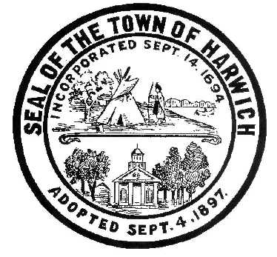 HARWICH
732 Main Street
Harwich, MA 02645
CONSERVATION COMMISSION
PHONE (508)-430-7538 FAX (508)430-7531
HARWICH CONSERVATION COMMISSION - AGENDA
TOWN HALL – GRIFFIN ROOM – HYBRID MEETING
WEDNESDAY AUGUST 3, 2022 – 6:30 PM
*Public may attend the meeting in person, access the meeting on Channel 18 (Broadcasting Live), or can login to the meeting remotely using the following login information*
Please join my meeting from your computer, tablet or smartphone.
https://meet.goto.com/999892341
You can also dial in using your phone.
United States: +1 (669) 224-3412
Access Code: 999-892-341
New to GoToMeeting? Download the App here: https://meet.goto.com/install
6:30 PM HEARINGS
All hearings shall be subject to discussion, taking of testimony, review of submitted and documents which may result in a vote being taken to approve or deny a project; or to issue a continuance to a time and date certain in order to receive and review further information as needed.
The following applicants have filed a Request for a Determination of Applicability
La Porteña Property Trust, 15 Lake Drive, Map 25 Parcel W1-8B. Proposed Vista Pruning.

Patricia Butler, 33 Uncle Venies Drive, Map 17 Parcel F1-1. Proposed Second Floor Addition.

The following applicants have filed a Notice of Intent
Donald Annino, 14 Mill Point Rd, Map 1 Parcel J1-94. Proposed Pier, Ramp, Float, and Dredging. Applicant has requested a continuance to the August 17, 2022 Meeting.

Michael Lach, Harwich Conservation Trust, Cold Brook Preserve, Map 23 Parcels C3-2, C1-0, and C1-1. Proposed Ecological Restoration.

Discussion and Possible Vote
2 Harvest Hollow – Discussion of unpermitted fence

374 Main St Bogs – Discussion of future use

Minutes
May 19, 2022
June 1, 2022
June 15, 2022
October 2, 2019

ANY OTHER BUSINESS WHICH MAY COME BEFORE THE COMMISSION
Authorized posting officer: Posted by: Town Clerk
Melyssa Millett 7/29/2022 Signature Date

