TOWN OF 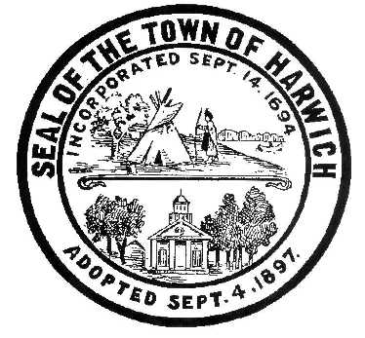 HARWICH
732 Main Street
Harwich, MA 02645

CONSERVATION COMMISSION
PHONE (508)-430-7538 FAX (508)430-7531
HARWICH CONSERVATION COMMISSION - AGENDA
AUGUST 4, 2021 6:30 PM
GRIFFIN ROOM – TOWN HALL

*Public may attend the meeting in person, access the meeting on Channel 18 (Broadcasting Live), or can login to the meeting using the following login information*

Please join my meeting from your computer, tablet or smartphone.
https://global.gotomeeting.com/join/403744325
You can also dial in using your phone.
United States: +1 (872) 240-3311
Access Code: 403-744-325

6:30 PM HEARINGS
All hearings shall be subject to discussion, taking of testimony, review of submitted and documents which may result in a vote being taken to approve or deny a project; or to issue a continuance to a time and date certain in order to receive and review further information as needed.
The following applicants have filed a Request for Determination of Applicability

Brian Higgins, 49 Snow Inn Road, Map 15 Parcel N2. Remove and replace existing float in new configuration. Applicant has requested to withdraw, without prejudice.

The following applicants have filed a Request for a Change in Plan

John F. and Joseph A. Barbati, 50 Marthas Lane, Map 43 Parcel B6-9. Request to change 224sqft of previously approved deck to a covered porch. The other 140sqft of deck will remain open.

The following applicants have filed a Notice of Intent

William and Caroline Counselman, 5 Fiddler’s Landing, Map 6 Parcel A1-8. Demo and replace a single family dwelling and make site improvements.

Ronald and Jennifer Paasch, 7 Prince Charles Drive, Map 110 Parcel S27. After-the-fact permit for shed and deck.

Orders of Conditions:
Ryan Cox, 9 Atlantic Ave, Map 6B Parcel L145. Bring existing dwelling up to FEMA compliance and make site improvements.
Mary Judge, 6 & 10 Neel Rd, Map 9, Parcels A7-1 and A7-2. Amended Order of Conditions SE32-2397. Repair third groin on property in conjunction with the previously approved repair of two other groins on the property.
Discussion and Possible Vote
Removal of un-permitted fence at 19 Wequasset Road
Update on 422 Main Street and 141 Riverside Drive violations
Update on 47 North Road
Discussion of possible town work at the end of Sea Street
MINUTES
April 7, 2021 Executive Session
December 2, 2020 Meeting
July 21, 2021 Meeting
ANY OTHER BUSINESS WHICH MAY COME BEFORE THE COMMISSION
Authorized posting officer: Posted by: Town Clerk
Melyssa Millett
Signature Date: 7/30/21

