+TOWN OF 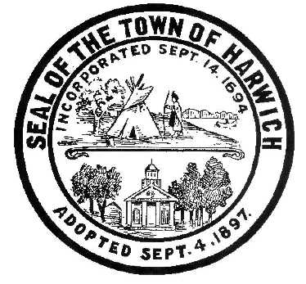 HARWICH
732 Main Street
Harwich, MA 02645
CONSERVATION COMMISSION
PHONE (508)-430-7538 FAX (508)430-7531
HARWICH CONSERVATION COMMISSION - AGENDA
TOWN HALL – SMALL HEARING ROOM– HYBRID MEETING
WEDNESDAY, AUGUST 5, 2022 12:00PM
*Remote access is available using the following login information*
Please join my meeting from your computer, tablet or smartphone.
https://meet.goto.com/263582373
You can also dial in using your phone.
United States: +1 (571) 317-3122
Access Code: 263-582-373
New to GoToMeeting? Get the app here: https://meet.goto.com/install

12PM EXECUTIVE SESSION
Discussion and possible vote on Superseding Order of Conditions SE32-2431 issued by MassDEP for 28 Wah Wah Taysee Rd, Map 6 Parcel F1-12.

Authorized posting officer: Posted by: Town Clerk
Melyssa Millett 8/3/2022 Signature Date

