TOWN OF 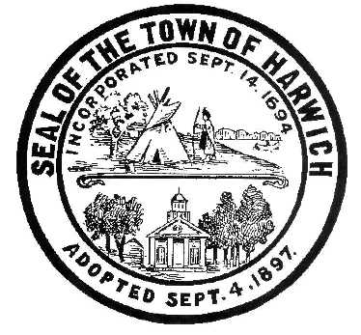 HARWICH
732 Main Street
Harwich, MA 02645
CONSERVATION COMMISSION PHONE (508)-430-7538 FAX (508)430-7531
HARWICH CONSERVATION COMMISSION - AGENDA
WEDNESDAY DECEMBER 18, 2019 – 6:30 PM
SMALL HEARING ROOM, HARWICH TOWN HALL
CALL TO ORDER
HEARINGS
***As required by Open Meeting Law, the Conservation Commission is informing the public that this meeting will be video recorded. Anyone else intending to record is required to inform the chairman prior to the meeting.
All hearings shall be subject to discussion, taking of testimony, review of submitted and documents which may result in a vote being taken to approve or deny a project; or to issue a continuance to a time and date certain in order to receive and review further information as needed.
Requests for Determination of Applicability
Ted Damico & Yvette Cozier, 11 Nehoiden Street, Map 12 Parcel 3X-3A. Replace a screened-in porch and car port on a slab foundation with an addition on a crawl-space foundation. Applicant has requested to withdraw application without prejudice.
Donna Smith, 296 Rt 28, Map 12 Parcel H1. Site reconfiguration with new snack shack and septic system.
Beth Winmill, Common area of Daisy St and Sequattom Rd, No Map or Parcel. Rebuild beach stairs.
Notices of Intent
Town of Harwich, 0 Cove Landing Rd, Map 115 Parcel P2. Reconstruction of boat ramp.

Mary Judge, 6 & 10 Neel Rd, Map 9 Parcel A7-1 & 2. Shorefront protection.
Rick & Linda Vayo, 0 Sequattom Rd, Map 101 Parcel W4-1. Dock.
Sheila & Alfred Quirk, 11 Prince Charles Dr, Map 110 Parcel S26. Addition, move outdoor shower, construct window well and plantings.
Aaron & Barbara Thall, 10 Chase St, Map 4 Parcel N3A. Pier, ramp, float, vista pruning.
Michael & Jennifer Monteiro, 11 Braddock St, Map 7 Parcel F19. Demo and rebuild dwelling.
Orders of Conditions
Jim Palermo, 27 Strandway, Map 1 Parcel J1-34. Hardscaping and planting.
Certificate of Compliance
James & Anne Tompkins, 4 Novotny Ln, Map 29 Parcel N1-2. Reissue certificate of compliance.
Minutes – vote shall be taken
May 1, 2019
Discussion and Possible Vote
Update on status of replanting at 141 Riverside Drive
Update on status of revegetation plan for 422 Main St
Update on status of plan for 23 Snow Inn Rd to change chemical use on the property.
Wetlands Protection Bylaw and Water Dependent Structures Bylaw and Regulations proposed changes.
ANY OTHER BUSINESS WHICH MAY COME BEFORE THE COMMISSION
Authorized posting officer: Posted by: Town Clerk
Nicole Smith_
Signature Date: 12/12/2019

