TOWN OF 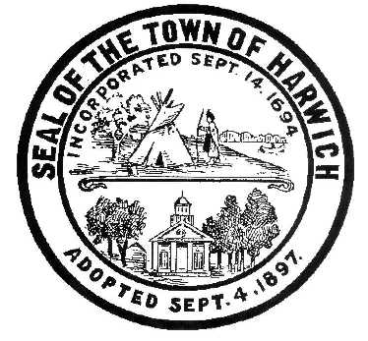 HARWICH
732 Main Street
Harwich, MA 02645
CONSERVATION COMMISSION
PHONE (508)-430-7538 FAX (508)430-7531
HARWICH CONSERVATION COMMISSION - AGENDA
TOWN HALL - GRIFFIN ROOM
DECEMBER 15, 2021 - 6:30 PM
*Public may attend the meeting in person, access the meeting on Channel 18 (Broadcasting Live), or can login to the meeting remotely using the following login information*
Please join my meeting from your computer, tablet or smartphone.
https://global.gotomeeting.com/join/980161557
You can also dial in using your phone.
United States: +1 (408) 650-3123
Access Code: 980-161-557
New to GoToMeeting? Get the app now and be ready when your first meeting starts: https://global.gotomeeting.com/install/980161557

6:30 PM HEARINGS
All hearings shall be subject to discussion, taking of testimony, review of submitted and documents which may result in a vote being taken to approve or deny a project; or to issue a continuance to a time and date certain in order to receive and review further information as needed.

The following applicants have filed a Notice of Intent

Virginia Nabors, 48 North Rd, Map 11 Parcel A1. Proposed Bulkhead and Fiber Rolls.

Michele McMahon, 10 Captain Scott Rd, Map 103 Parcel W1-19. Proposed Seasonal Dock.

Mark and Debra Ellis, 23 Mill Rd, Map 15 Parcel U4-32. Proposed access steps, elevated walkway, and vista management. Applicant has requested a continuance to January 5, 2022.

Orders of Conditions
James Carney, 6 Saquatucket Point, Map 8 Parcel G1-9. Proposed Addition, Garage Expansion, and Septic Upgrade.

The following applicants have requested to Extend an Order of Conditions

Steven Szafran, 177 Forest Street, Map 31 Parcel C2, SE32-2247. Replacement of old hardscape and installation of new hardscape. Requests additional 2 month extension.

The following applicants have requested a Certificate of Compliance

Andrea Besse, 61 Lovers Lane, Map 41 Parcel M1-2, SE32-2031. Constructing of swelling on pre-existing foundation and associated plantings.

Minutes
January 6, 2021
September 1, 2021
October 6, 2021

Discussion and Possible Vote
Proposed changes to the draft Harwich Wetlands Protection Bylaw
Update on Violations: 7 Prince Charles Drive, 11 River Bend

Proposed harvest and sale of vines and surplus equipment at Bells Neck Bogs

ANY OTHER BUSINESS WHICH MAY COME BEFORE THE COMMISSION
Authorized posting officer: Posted by: Town Clerk
Melyssa Millett
Signature Date: 12/10/2021

