TOWN OF 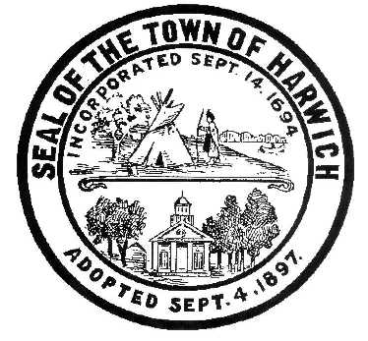 HARWICH
732 Main Street
Harwich, MA 02645
CONSERVATION COMMISSION
PHONE (508)-430-7538 FAX (508)430-7531
HARWICH CONSERVATION COMMISSION - AGENDA
TOWN HALL - GRIFFIN ROOM
DECEMBER 1, 2021 - 6:30 PM

*Public may attend the meeting in person, access the meeting on Channel 18 (Broadcasting Live), or can login to the meeting remotely using the following login information*

Please join my meeting from your computer, tablet or smartphone.
https://global.gotomeeting.com/join/336569333
You can also dial in using your phone.
United States: +1 (872) 240-3212
Access Code: 336-569-333
New to GoToMeeting? Get the app now and be ready when your first meeting starts: https://global.gotomeeting.com/install/336569333

6:30 PM HEARINGS
All hearings shall be subject to discussion, taking of testimony, review of submitted and documents which may result in a vote being taken to approve or deny a project; or to issue a continuance to a time and date certain in order to receive and review further information as needed.

The following applicants have filed a Request for Determination of Applicability
Michael Ahearn, 17 Woodbine Rd, Map 12 Parcel X1-29. Proposed Screened Porch Addition.

The following applicants have filed a Notice of Intent

Virginia Nabors, 48 North Rd, Map 11 Parcel A1. Proposed Bulkhead and Fiber Rolls.

Michele McMahon, 10 Captain Scott Rd, Map 103 Parcel W1-19. Proposed Seasonal Dock.

Jonathan & Maureen Ellis, Bruce & Mary Catherine Ring, 0 Pleasant Lake Ave, Map 101 Parcel P1-0. Proposed Seasonal Dock.

James Carney, 6 Saquatucket Point, Map 8 Parcel G1-9. Proposed Addition, Garage Expansion, and Septic Upgrade.

Orders of Conditions
Brian Hellauer, 4 Shady Dr, Map 73 Parcel X180. New dwelling and appurtenances.

Wesley Price, 0 Clearwater Dr, Map 73 Parcels P94 & P95. New dwelling and appurtenances.

The following applicants have requested to Extend an Order of Conditions

Steven Szafran, 177 Forest Street, Map 31 Parcel C2, SE32-2247. Replacement of old hardscape and installation of new hardscape. Requests additional 2 month extension.

The following applicants have requested a Certificate of Compliance
Robert and Rosanne Theobald, 73 Gilbert Lane, Map 30 Parcel D2-6. SE32-953. Septic Replacement and Addition.

Minutes
September 1, 2021
October 6, 2021
October 20, 2021

Discussion and Possible Vote
Proposed changes to the draft Harwich Wetlands Protection Bylaw
Update on Violations

ANY OTHER BUSINESS WHICH MAY COME BEFORE THE COMMISSION
Authorized posting officer: Posted by: Town Clerk
Melyssa Millett
Signature Date: 11/24/21

