TOWN OF 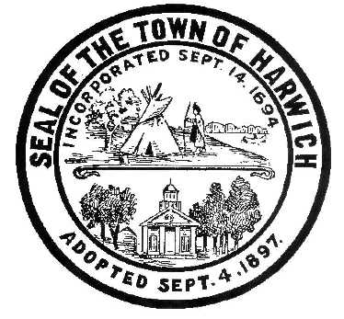 HARWICH
732 Main Street
Harwich, MA 02645
PHONE (508)-430-7538 FAX (508)430-7531
HARWICH CONSERVATION COMMISSION - MEETING AGENDA
TOWN HALL - GRIFFIN ROOM - DECEMBER 21, 2022 – 6:30 PM
*Public may attend the meeting in person, access the meeting on Channel 18 (Broadcasting Live), or can login to the meeting remotely using the following login information*
To join the meeting from your computer, tablet or smartphone, follow this link:
https://meet.goto.com/169320933
You can also dial in using your phone.
United States: +1 (571) 317-3122
Access Code: 169-320-933

New to GoToMeeting? Download the App here: https://meet.goto.com/install

6:30 PM HEARINGS
All hearings shall be subject to discussion, taking of testimony, review of submitted and documents which may result in a vote being taken to approve or deny a project; or to issue a continuance to a time and date certain in order to receive and review further information as needed.
The following applicants have filed a Request for Determination of Applicability
Jack Jacobs, 89 Shore Rd, Map 5 Parcel P1-4. Deck Expansion.

The following applicants have requested a Change in Plan
Tom Smith, 52 North Rd, Map 19 Parcel S1. RDA 2019-7. Septic System Installation.

The following applicants have requested an Amended Order of Conditions
Tom Smith, 47 North Rd, Map 19 Parcel S2. SE32- 2373. Septic System Installation.

The following applicants have filed a Notice of Intent
Daniel Mento, 3 Mark Lane, Map 30 Parcel G5-3. New Dwelling and appurtenances.

Donald Annino, 14 Mill Point Rd, Map 1 Parcel J1-94. Proposed Pier, Ramp, Float, and Dredging. Applicant has requested a continuance to the February 1, 2023 Meeting.

Orders of Conditions
Jane C. Ayoub, 23 Sound View Rd, Map 26 Parcel L1-10. SE32-2516. Detached Garage.

Tom Smith, 47 North Rd, Map 19 Parcel S2. Amendment to SE32- 2428. Bulkhead Repair.

The following applicants have requested a Certificate of Compliance
Christina Freeman, 19 Nons Rd, Map 6 Parcel C1-12. SE32-2349. Additions.

Sharon Mabile, 43 Shore Rd, Map 2 Parcel B14. SE32-1272. Seaweed Removal.

Therese Nolan, 5 Brooks Rd, Map 5 Parcel A1-2. SE32-2405. Demo & Rebuild.

Show Cause Hearing
Texeira Conservation Lands – Unpermitted dumping and creation of trails on Town-owned Conservation land

117 Riverside Drive – Unpermitted cutting of vegetation within the Riverfront Area and Buffer Zone

Discussion and Possible Vote
Proposed Wychmere Habitat Conservation Plan
Update on ongoing land management tasks:
Herring River Study
Bells Neck Land Management Plan Revision

Minutes
November 6, 2019
November 20, 2019

ANY OTHER BUSINESS WHICH MAY COME BEFORE THE COMMISSION
Authorized posting officer: Posted by: Town Clerk
Melyssa Millett
Signature Date:

