TOWN OF 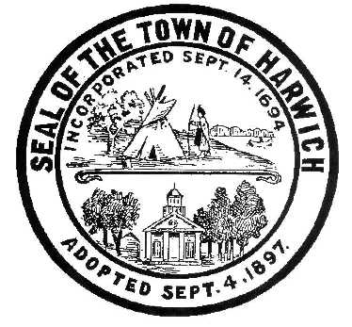 HARWICH
732 Main Street
Harwich, MA 02645
PHONE (508)-430-7538 FAX (508)430-7531
HARWICH CONSERVATION COMMISSION - MEETING AGENDA
TOWN HALL - GRIFFIN ROOM
WEDNESDAY – FEBRUARY 15, 2023 – 6:30 PM
*Public may attend the meeting in person, access the meeting on Channel 18 (Broadcasting Live), or can login to the meeting remotely using the following login information*

Please join my meeting from your computer, tablet or smartphone:
https://meet.goto.com/653549965
You can also dial in using your phone.
Access Code: 653-549-965
United States: +1 (669) 224-3412
New to GoToMeeting? Download the App here: https://meet.goto.com/install

6:30 PM HEARINGS
All hearings shall be subject to discussion, taking of testimony, review of submitted and documents which may result in a vote being taken to approve or deny a project; or to issue a continuance to a time and date certain in order to receive and review further information as needed.
The following applicants have requested a Determination of Applicability

Narcisa Dervishevikj, 1232 Orleans Rd, Map 73 Parcel X172. Proposed Access Path and Rebuild of Stairs.

The following applicants have requested an Amended Order of Conditions

Wychmere Harbor Real Estate LLC, 23 Snow Inn Rd, Map 8 Parcel P2. SE32-2387. NHESP File #11-29126. Reconfiguration of beach grass mitigation area, and incorporation of HCP filed with NHESP.

The following applicants have filed a Notice of Intent
William Beekman, 194 John Joseph Rd, Map 72 Parcel G1-2. Construction of Retaining Walls, Reconstruction of Patio and Deck, and Site Improvements.

John Leong and Charis Cladouhos, 25 Trout Brook & 27 Sound View Rd, Map 26 Parcels C1-6 & L1-9. Construct Reinforcing Retaining Wall.

Pleasant Bay Community Boating, 2285 & 2287 Rte 28 – Head of the Bay Rd, Map 119 Parcels N7-3 & N8-0. Changes to parking areas, retaining walls, walkways, stairs, and deck.

Round Cove Resort Owner LLC, 2173 Rt 28 – Head of the Bay Rd & 4 Cove Landing Rd, Map 115 Parcels S1-3 & R2. Raze and Replace Buildings A, B, and K, Planting, and Hardscape Improvements.

HFH Development, (4, 8, 11, 12, 16, 17, 20) Chloe’s Path & 0 Forest St, Map 31 Parcels D4-3, D4-4, D4-5, D4-6, D4-7, D4-8, D-4-9, & D3. Re-establishment of the turtle protection plan set forth in NHESP 09-20086.

Enforcement Orders
117 & 123 Riverside Dr – Review of proposed restoration plan

Orders of Conditions
Harbourwatch Condominium Association, 363-371 Route 28, Map 13 Parcel A8-1. SE32-2520. Vista Pruning.

Vincent Petroni, 31 Shore Rd, Map 2 Parcel B1-7. Amendment to SE32-2430. Bank stabilization, replacement of existing deck, and removal of existing stairs and reconstruction in new location.

The following applicants have requested a Certificate of Compliance
Rocco Orsini, 56 Purmackene Ln, Map 24 Parcel H17. SE32-2293. New dwelling and appurtenances.

Discussion and Possible Vote:
Update on ongoing land management tasks:
Herring River Study

Minutes
September 21, 2022
October 5, 2022
January 27, 2023

ANY OTHER BUSINESS WHICH MAY COME BEFORE THE COMMISSION
Authorized posting officer: Posted by: Town Clerk
Melyssa Millett
Signature Date:

