TOWN OF 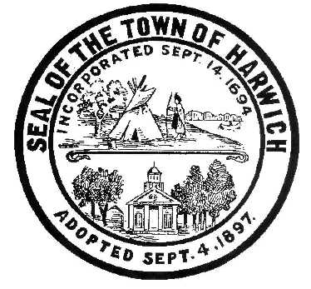 HARWICH
732 Main Street
Harwich, MA 02645
CONSERVATION COMMISSION
PHONE (508)-430-7538 FAX (508)430-7531
HARWICH CONSERVATION COMMISSION - AGENDA
TOWN HALL - GRIFFIN ROOM
FEBRUARY 16, 2022 - 6:30 PM
*Public may attend the meeting in person, access the meeting on Channel 18 (Broadcasting Live), or can login to the meeting remotely using the following login information*
Please join my meeting from your computer, tablet or smartphone.
https://global.gotomeeting.com/join/788780197
You can also dial in using your phone.
United States: +1 (408) 650-3123
Access Code: 788-780-197
New to GoToMeeting? Get the app now and be ready when your first meeting starts: https://global.gotomeeting.com/install/788780197

6:30 PM HEARINGS
All hearings shall be subject to discussion, taking of testimony, review of submitted and documents which may result in a vote being taken to approve or deny a project; or to issue a continuance to a time and date certain in order to receive and review further information as needed.
The following applicants have filed a Request for Determination of Applicability

Eastward Companies, 0 Route 39/Orleans Rd, Map 63 Parcel C3. Request that the Conservation Commission make a determination that the area depicted on the proposed plans is an area subject to the protection of the Massachusetts Wetlands Protection Act, and whether the boundaries of the wetland resource areas depicted on the plans are accurately delineated.

The following applicants have filed a Notice of Intent

Anita and Kristopher Jong, 2 Millers Toll Rd, Map 111 Parcel K3-3. Raze and replace SF dwelling, with new addition.

William and Nancy Doherty, 20 Chase St, Map 4 Parcel N2-2. Replacement of dock and float.

Joseph and Linda O’Neill, 1 Salt Meadow Lane, Map 11 Parcel C1. Construction of a sloped revetment and replacement of existing dock.

Orders of Conditions

George Seiler, 25 Belle Brook Ln, Map 23 Parcel X6. Amendment to SE32-2477. Addition of a garage and relocation of the dwelling.

Minutes
March 3, 2021
May 19, 2021
November 3, 2021
November 17, 2021

Discussion and Possible Vote

Update on Violations: 65 Snow Inn & 22 Harbor Rd

ANY OTHER BUSINESS WHICH MAY COME BEFORE THE COMMISSION
Authorized posting officer: Posted by: Town Clerk
Melyssa Millett
Signature Date: 2/11/2022

