TOWN OF 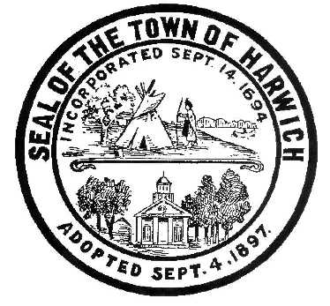 HARWICH
732 Main Street
Harwich, MA 02645
PHONE (508)-430-7538 FAX (508)430-7531
HARWICH CONSERVATION COMMISSION - MEETING AGENDA
TOWN HALL - GRIFFIN ROOM
WEDNESDAY – FEBRUARY 1, 2023
Executive Session – 6:00 PM
Regular Session – 6:30 PM
*Public may attend the meeting in person, access the meeting on Channel 18 (Broadcasting Live), or can login to the meeting remotely using the following login information*
Please join my meeting from your computer, tablet or smartphone.
https://meet.goto.com/655059661

You can also dial in using your phone.
Access Code: 655-059-661
United States: +1 (872) 240-3212

New to GoToMeeting? Download the App here: https://meet.goto.com/install

6:00 PM EXECUTIVE SESSION
Executive Session Minutes – October 5, 2022 and January 4, 2023
Update on ongoing litigation – 47 & 52 North Rd

6:30 PM HEARINGS
All hearings shall be subject to discussion, taking of testimony, review of submitted and documents which may result in a vote being taken to approve or deny a project; or to issue a continuance to a time and date certain in order to receive and review further information as needed.
The following applicants have requested a Determination of Applicability
Osborne Bearse, 0 Sequattom Rd, Map 101 Parcel R4-3. Construct wooden stairs over existing concrete steps.

The following applicants have requested an Amended Order of Conditions
Vincent Petroni, 31 Shore Rd, Map 2 Parcel B1-7. SE32-2430. Bank stabilization, replacement of existing deck, and removal of existing stairs and reconstruction in new location.

The following applicants have filed a Notice of Intent
Harbourwatch Condominium Association, 363-371 Route 28, Map 13 Parcel A8-1. Vista Pruning.

Donald Annino, 14 Mill Point Rd, Map 1 Parcel J1-94. Proposed Pier, Ramp, Float, and Dredging. Applicant had requested a continuance to the March 1, 2023 meeting.

HFH Development, (4, 8, 11, 12, 16, 17, 20) Chloe’s Path & 0 Forest St, Map 31 Parcels D4-3, D4-4, D4-5, D4-6, D4-7, D4-8, D-4-9, & D3. Re-establishment of the turtle protection plan set forth in NHESP 09-20086.

Discussion and Possible Vote
As-Built Road Plan for Chloe’s Path

Show Cause Hearing
38 Red Pine Drive - Unauthorized tree removal

Orders of Conditions
James & Tracy Fish, 61 Shore Rd, Map 2 Parcel B1-1. SE32-2517. Raze & Replace Dwelling with Appurtenances and Beach Access.

The following applicants have requested a Certificate of Compliance
Chris Cooney, 4 Geraldine Ave, Map 16 Parcel A1-6. SE32-2462. Addition and pool.

Discussion and Possible Vote
Update on ongoing land management tasks:
Herring River Study

Minutes
September 7, 2022
September 21, 2022

ANY OTHER BUSINESS WHICH MAY COME BEFORE THE COMMISSION
Authorized posting officer: Posted by: Town Clerk
Melyssa Millett
Signature Date:

