**TOWN *OF*** *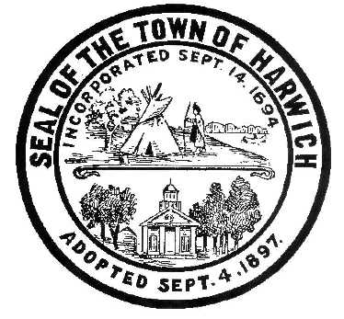* ***HARWICH***

***HARWICH ACCESSIBILITY RIGHTS COMMITTEE***

***Harwich Town Hall LIBRARY Conference Room***

***Thursday, April 25, 2018 6:30 PM***

***AGENDA***

Attendance and Introductions:

MINUTES: Review & Approval

OPEN FORUM:

OLD BUSINESS:

1. Status of Municipal ADA Improvement Grant, for Self-Evaluation Transition
2. Status of CDBG Grant for Harwich Center Sidewalk replacement & Traffic Lights
3. Status of School Student Access Sidewalk Grant for Sisson Road (Approved)
4. Status of 2019 Town Meeting Video Wall Screen & Audio Head-phone area
5. Status of 2019 Town Meeting Vision Handicap Voting Machine, Assistance & Access
6. Status of 2019 HARC Absentee Voting and Ballot Mail-in Process
7. Status of ADA Compatible Sidewalk & Traffic Light from Bank St. to Saquatucket

NEW BUSINESS:

1. Need for a Sidewalk on Rt. 39 from Harwich Center to Cape Cod Tech
2. Need for a Sidewalk on Queen Ann Road from Rt .39 to Rt. 124 Rotary, & Rt. 137
3. Need to Reduce the Speed limit to 25 MPH, on Queen Ann Road; Rt. 124 to Rt. 39
4. Request to MA to have a 5-cent deposit on all plastic bottles & ‘Liquor Nips’

MONTHLY REPORTS:

Harwich Board of Selectmen

Harwich Town Administrator

CORRESPONDANCE:

NEXT MEETING: Thursday May 23, 2019

ADJOURNMENT:

Posting Date: 04/13/19 W. Matthew Hart, Chairman Matt's Signature2_Pic1

*The committee may hold an open session for topics not reasonably anticipated by the Chair 48 hours in advance of the meeting following “New Business.” If you are deaf or hard of hearing or a person with a disability who requires an accommodation, contact the Selectmen’s Office at 508-430-7513***.**