**TOWN *OF*** *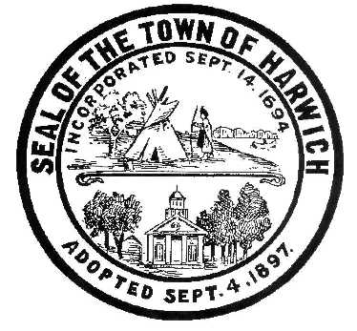* ***HARWICH***

***HARWICH ACCESSIBILITY RIGHTS COMMITTEE***

***Harwich Town Hall LIBRARY Conference Room***

***Thursday, January 24, 2019 6:30 PM***

***AGENDA***

Attendance and Introductions:

MINUTES: Review & Approval

OPEN FORUM:

OLD BUSINESS:

1. Discussion about changes to the CDBG Sidewalk Application
2. Up-date on ADA Self-Evaluation Transition Plan
3. Up-date on ADA Transition Grant

NEW BUSINESS:

1. Discussion about the ADA Sidewalk Signs at Planning Board Meeting
2. Committee Signatures on Chairman’s ADA Meeting Travel Expense Voucher for 2018

MONTHLY REPORTS:

Board of Selectmen

CORRESPONDANCE:

1. Assigned Budget for HARC in 2019

NEXT MEETING:

ADJOURNMENT:

Posting Date: Jan. 09, 2019 W. Matthew Hart, Chairman Matt's Signature2_Pic1

*The committee may hold an open session for topics not reasonably anticipated by the Chair 48 hours in advance of the meeting following “New Business.” If you are deaf or hard of hearing or a person with a disability who requires an accommodation, contact the Selectmen’s Office at 508-430-7513***.**