**TOWN *OF*** *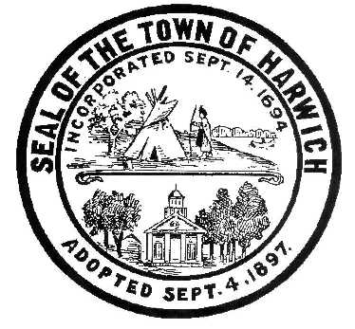* ***HARWICH***

***HARWICH ACCESSIBILITY RIGHTS COMMITTEE***

***Harwich Town Hall LIBRARY Conference Room***

***Thursday, November 28 , 2019 6:30 PM***

***AGENDA***

**Since the fourth Thursday of November (28th) is a holiday there will not be a HARC Meeting. I understand that there will be one and possibly two new members joining the committee and that Gary Miller, has resigned because he moved to Georgia.**

**The next meeting is scheduled to be in December on the 26th, which is Christmas Day, so I’m suggesting we meet the week before on Thursday December 19, 2019**

Attendance and Introductions:

MINUTES: Review & Approval

OPEN FORUM:

NEW BUSINESS:

OLD BUSINESS:

MONTHLY REPORTS:

Board of Selectmen

CORRESPONDANCE:

NEXT MEETING:

ADJOURNMENT:

Posting Date: W. Matthew Hart, Chairman Matt's Signature2_Pic1

*The committee may hold an open session for topics not reasonably anticipated by the Chair 48 hours in advance of the meeting following “New Business.” If you are deaf or hard of hearing or a person with a disability who requires an accommodation, contact the Selectmen’s Office at 508-430-7513***.**