**TOWN *OF*** *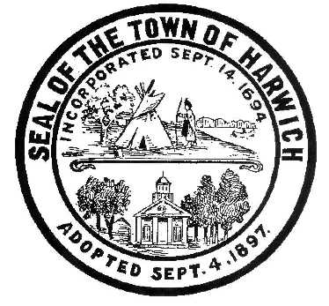* ***HARWICH***

***HARWICH ACCESSIBILITY RIGHTS COMMITTEE***

***Harwich Town Hall LIBRARY Conference Room***

***Thursday, September, 26, 2019 6:30 PM***

***AGENDA***

Attendance and Introductions:

MINUTES: Review & Approval

OPEN FORUM:

NEW BUSINESS:

1. Up-dates on HARC Projects
2. Up-dates on New & Replacement Sidewalks
3. Re-application for 2019 ADA Municipal Grant

OLD BUSINESS:

1. New HARC Members

MONTHLY REPORTS:

Board of Selectmen

CORRESPONDANCE:

NEXT MEETING: October24, 2019

ADJOURNMENT:

Posting Date: 09/21/2019 W. Matthew Hart, Chairman Matt's Signature2_Pic1

*The committee may hold an open session for topics not reasonably anticipated by the Chair 48 hours in advance of the meeting following “New Business.” If you are deaf or hard of hearing or a person with a disability who requires an accommodation, contact the Selectmen’s Office at 508-430-7513***.**