TOWN OF 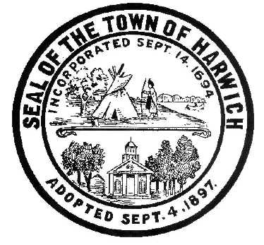 HARWICH
732 Main Street
Harwich, MA 02645
PHONE (508)-430-7538 FAX (508)430-7531
HARWICH CONSERVATION COMMISSION - MEETING AGENDA
TOWN HALL – SMALL HEARING ROOM
FRIDAY - JANUARY 27, 2023 – 2:00 PM

Discussion and Possible Vote
Work session on proposed revisions to the Bells Neck Land Management Plan

Authorized posting officer: Posted by: Town Clerk
Melyssa Millett
Signature Date: _

