TOWN OF 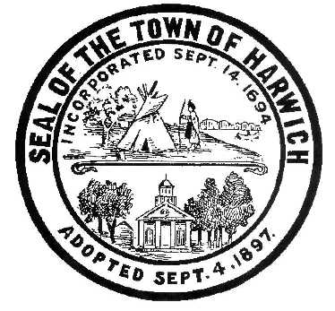 HARWICH
732 Main Street
Harwich, MA 02645
CONSERVATION COMMISSION
PHONE (508)-430-7538 FAX (508)430-7531
HARWICH CONSERVATION COMMISSION - AGENDA
TOWN HALL - GRIFFIN ROOM
JANUARY 5, 2022 - 6:30 PM
REVISED
*Public may attend the meeting in person, access the meeting on Channel 18 (Broadcasting Live), or can login to the meeting remotely using the following login information*
Please join my meeting from your computer, tablet or smartphone.
https://global.gotomeeting.com/join/469616493
You can also dial in using your phone.
United States: +1 (571) 317-3122
Access Code: 469-616-493
New to GoToMeeting? Get the app now and be ready when your first meeting starts: https://global.gotomeeting.com/install/469616493

6:30 PM HEARINGS
All hearings shall be subject to discussion, taking of testimony, review of submitted and documents which may result in a vote being taken to approve or deny a project; or to issue a continuance to a time and date certain in order to receive and review further information as needed.

The following applicants have filed a Request for Determination of Applicability

James O’Neil, 5 Sunset Rd, Map 12 Parcel T4-8. Construction of a covered porch on an existing dwelling.

The following applicants have filed a Notice of Intent

David Norlander, 602 Queen Anne Rd, Map 83 Parcel S2. Proposed trash removal, replanting, walkway, planting beds, and patio.

Mark and Debra Ellis, 23 Mill Rd, Map 15 Parcel U4-32. Proposed access steps, elevated walkway, and vista management. Applicant has requested a continuance to January 5, 2022.

Orders of Conditions

Virginia Nabors, 48 North Rd, Map 11 Parcel A1. Proposed Bulkhead and Fiber Rolls.

Michele McMahon, 10 Captain Scott Rd, Map 103 Parcel W1-19. Proposed Seasonal Dock.

The following applicants have requested a Certificate of Compliance

Susan Hollis, 9 Stanley Rd, Map 81 Parcel A11. Vegetation Management.

Minutes
January 20, 2021
January 26, 2021
February 3, 2021
September 1, 2021
November 3, 2021

Discussion and Possible Vote
Update on Violations: 11 River Bend, 7 Prince Charles, 0 Snow Inn

Proposed harvest and sale of vines and surplus equipment at Bells Neck Bogs

ANY OTHER BUSINESS WHICH MAY COME BEFORE THE COMMISSION
Authorized posting officer: Posted by: Town Clerk
Melyssa Millett
Signature Date: 12/30/2021

