+TOWN OF 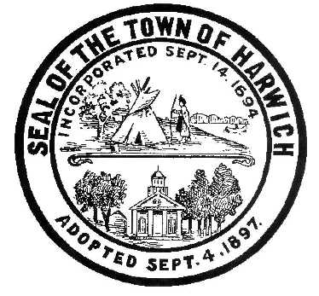 HARWICH
732 Main Street
Harwich, MA 02645
CONSERVATION COMMISSION
PHONE (508)-430-7538 FAX (508)430-7531
HARWICH CONSERVATION COMMISSION - AGENDA
TOWN HALL – GRIFFIN ROOM – WEDNESDAY JULY 6, 2022
Executive Session – 6:00PM
Regular Session – 6:30 PM
REVISED 7/1/2022
*Public may attend the meeting in person, access the meeting on Channel 18 (Broadcasting Live), or can login to the meeting remotely using the following login information*
Please join my meeting from your computer, tablet or smartphone.
https://meet.goto.com/564630997
You can also dial in using your phone.
United States: +1 (571) 317-3122
Access Code: 564-630-997 New to GoToMeeting? Download the App here: https://meet.goto.com/install
6:00 PM EXECUTIVE SESSION
Update and possible vote on Court Cases – 47 & 52 North Rd
3/16/22 Executive Session Minutes
6:30 PM HEARINGS
All hearings shall be subject to discussion, taking of testimony, review of submitted and documents which may result in a vote being taken to approve or deny a project; or to issue a continuance to a time and date certain in order to receive and review further information as needed.
Vote
Vote to give approval for submission of the LAND Grant application for the 0 Spruce Rd property

The following applicants have filed a Request for a Determination of Applicability
Douglas and Emma Karlson, 100 Grey Neck Rd, Map 11 Parcel X5. Septic Upgrade.

Kathleen Steves, 426 Main St, Map 47 Parcel A3-1. Proposed Addition, Deck Expansion, and Tree Removal.
Paul and Susan Cicco, 45 Neel Rd, Map 16 Parcel N1-41. Proposed Addition, Pool, Pool House and Hardscape.

Tom Smith, 52 North Rd, Map 19 Parcel S1. Have requested a change to the 2019 Determination and approved plan as part of the following request for an Amended Order for 47 North Rd.

The following applicants have requested an Amended Order of Conditions
Tom Smith, 47 North Rd, Map 19 Parcel S2. Have requested to amend Order of Conditions SE32- 2373 to allow for the installation of a sewage ejector and force main in place of the approved tight tank installation.

The following applicants have filed a Notice of Intent
Donald Annino, 14 Mill Point Rd, Map 1 Parcel J1-94. Proposed Pier, Ramp, Float, and Dredging. Applicant has requested a continuance to the July 20, 2022 Meeting.

Michael Lach, Harwich Conservation Trust, Cold Brook Preserve, Map 23 Parcels C3-2, C1-0, and C1-1. Ecological Restoration. Applicant has requested a continuance to the July 20, 2022 Meeting.

Orders of Conditions
Catherine Shanahan, 47 Saquatucket Bluffs Rd, Map 9 Parcel A1-3. Beach Access Stairs.

The following applicants have requested a Certificate of Compliance
Craig Borden, 2A Hinckley Rd, Map 91 Parcel J3-8. SE32-2266. Seasonal Dock and Boathouse Reconstruction.

Mark McKenney, 44 Smith St, Map 19 Parcel A5. SE32-2309. Construction of Metal Accessory Building.

Christine McBennett, 19 Shore Rd, Map B1 Parcel 10. SE32-1477. Installation of Septic System.

Martin Leddy, 34 Red Pine Dr, Map 82 Parcel X18. SE32-2454. New Dwelling and Appurtenances.

Discussion and Possible Vote

163 Sisson Rd – Discussion and possible vote about unpermitted activity and actions taken since

2 Harvest Hollow – Discussion and possible vote about unpermitted fence

Vote to appoint Conservation liaison to CPC

Minutes
April 20, 2022
May 4, 2022
June 28, 2022 On-Site

ANY OTHER BUSINESS WHICH MAY COME BEFORE THE COMMISSION
Authorized posting officer: Posted by: Town Clerk
Melyssa Millett 7/1/2022 Signature Date

