TOWN OF 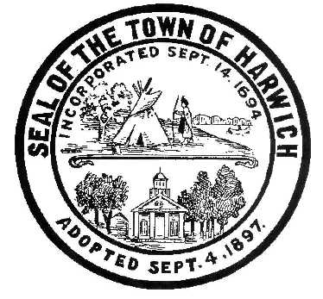 HARWICH
732 Main Street
Harwich, MA 02645
CONSERVATION COMMISSION
PHONE (508)-430-7538 FAX (508)430-7531
HARWICH CONSERVATION COMMISSION - AGENDA
TOWN HALL – GRIFFIN ROOM
WEDNESDAY JUNE 15, 2022 - 6:30 PM
*Public may attend the meeting in person, access the meeting on Channel 18 (Broadcasting Live), or can login to the meeting remotely using the following login information*
Please join my meeting from your computer, tablet or smartphone.
https://meet.goto.com/130917245
You can also dial in using your phone.
United States: +1 (224) 501-3412
Access Code: 130-917-245
New to GoToMeeting? Download the App here: https://meet.goto.com/install
HEARINGS
All hearings shall be subject to discussion, taking of testimony, review of submitted and documents which may result in a vote being taken to approve or deny a project; or to issue a continuance to a time and date certain in order to receive and review further information as needed.
The following applicants have filed a Request for a Determination of Applicability
John and Pamela Connor, 10 Doane Way, Map 13 Parcel X1-7. Pool and Septic.

Tom Smith, 52 North Rd, Map 19 Parcel S1. Have requested a change to the 2019 Determination and approved plan as part of the following request for an Amended Order for 47 North Rd.

The following applicants have requested an Amended Order of Conditions
Tom Smith, 47 North Rd, Map 19 Parcel S2. Have requested to amend Order of Conditions SE32- 2373 to allow for the installation of a sewage ejector and force main in place of the approved tight tank installation.

The following applicants have filed a Notice of Intent
Catherine Shanahan, 47 Saquatucket Bluffs Rd, Map 9 Parcel A1-3. Beach access stairs.

Peter McAree, Inn on the Beach, 16 Bank St, Map 7 Parcel F2. Beach Cleaning and Nourishment.

Donald Annino, 14 Mill Point Rd, Map 1 Parcel J1-94. Proposed Pier, Ramp, Float, and Dredging.

Michael Lach, Harwich Conservation Trust, Cold Brook Preserve, Map 23 Parcels C3-2, C1-0, and C1-1. Ecological Restoration.

Orders of Conditions
Alfred Weaver, 23 Wequasset Rd, Map 5 Parcel K1-42. Planting and Marsh enhancement.

Mark Carafella, 91 Punkhorn Rd, Map 100 Parcel A5. Raze and replace single family dwelling with deck

James Sullivan, 2 Brora Drive, Map 15 Parcel V1-3. Amendment for OOC SE32-2465. Single family home and accessory garage, landscaping and invasive species removal. Amendment is to add a plunge pool, pool patio, and relocate driveway.

Jonathan and Sarah Vanica, 2 Quason Lane, Map 7, Parcel A50. Amendment for OOC SE32-2434. Proposed removal and reconstruction of a single-family dwelling and associated site improvements. Amendment is for changes to hardscape.

Discussion and Possible Vote
374 Main Street - General Discussion about the Commission’s property and possible proposed future activities there.

Minutes
March 16, 2022
April 6, 2022
April 20, 2022
May 4, 2022

ANY OTHER BUSINESS WHICH MAY COME BEFORE THE COMMISSION
Authorized posting officer: Posted by: Town Clerk
Melyssa Millett
Signature Date

