TOWN OF 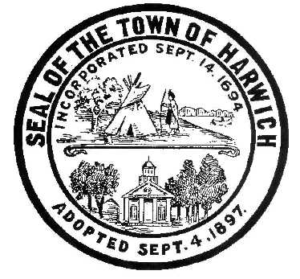 HARWICH
732 Main Street
Harwich, MA 02645
CONSERVATION COMMISSION
PHONE (508)-430-7538 FAX (508)430-7531
HARWICH CONSERVATION COMMISSION - AGENDA
TUESDAY JUNE 28, 2022 – 3:00 PM
ON-SITE AT ROBERT F. SMITH COLD BROOK PRESERVE

Members of the Harwich Conservation Commission shall meet on-site at the Robert F. Smith Cold Brook Preserve to view the proposed eco-restoration project location and review the project details with the Applicant and their Representatives.

Authorized posting officer: Posted by: Town Clerk
Melyssa Millett 6/24/2022
Signature Date

